# STM32 Mini Printer

Parts Explanation:

Step down converter: dc converter that reduces in put voltage to a lower output voltage

Arduino: brain of the project, controls robot

# Mini打印机Project教程(STM32 knowledge PCB design)

<https://x509p6c8to.feishu.cn/docx/JmWhd7qThofnSvx7V87cgvoXnue>

Password: HN1b816H

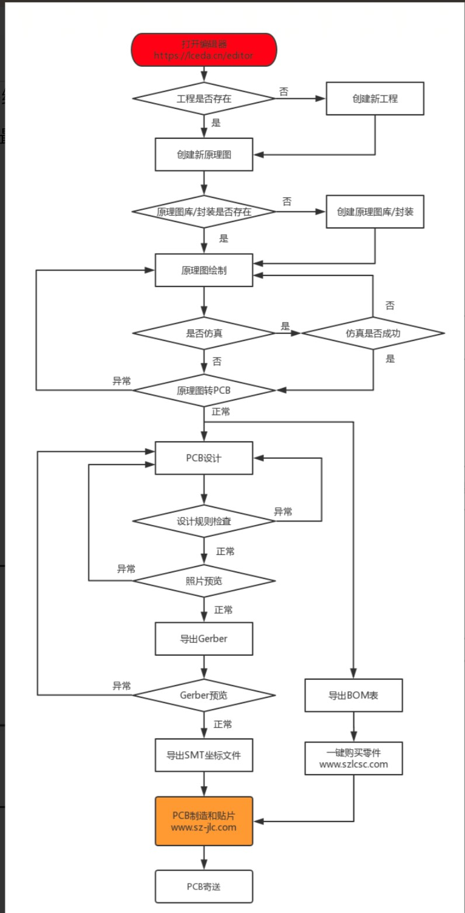

STM 32 Cube MX Design:

确定⽤哪⼀个STM32的芯⽚和确定STM32的对应IO位置

file:///Users/hugoq1/Downloads/stm32f103cb.pdf

以图下红⾊标的那⼀个来确认123456等等等然后看default function

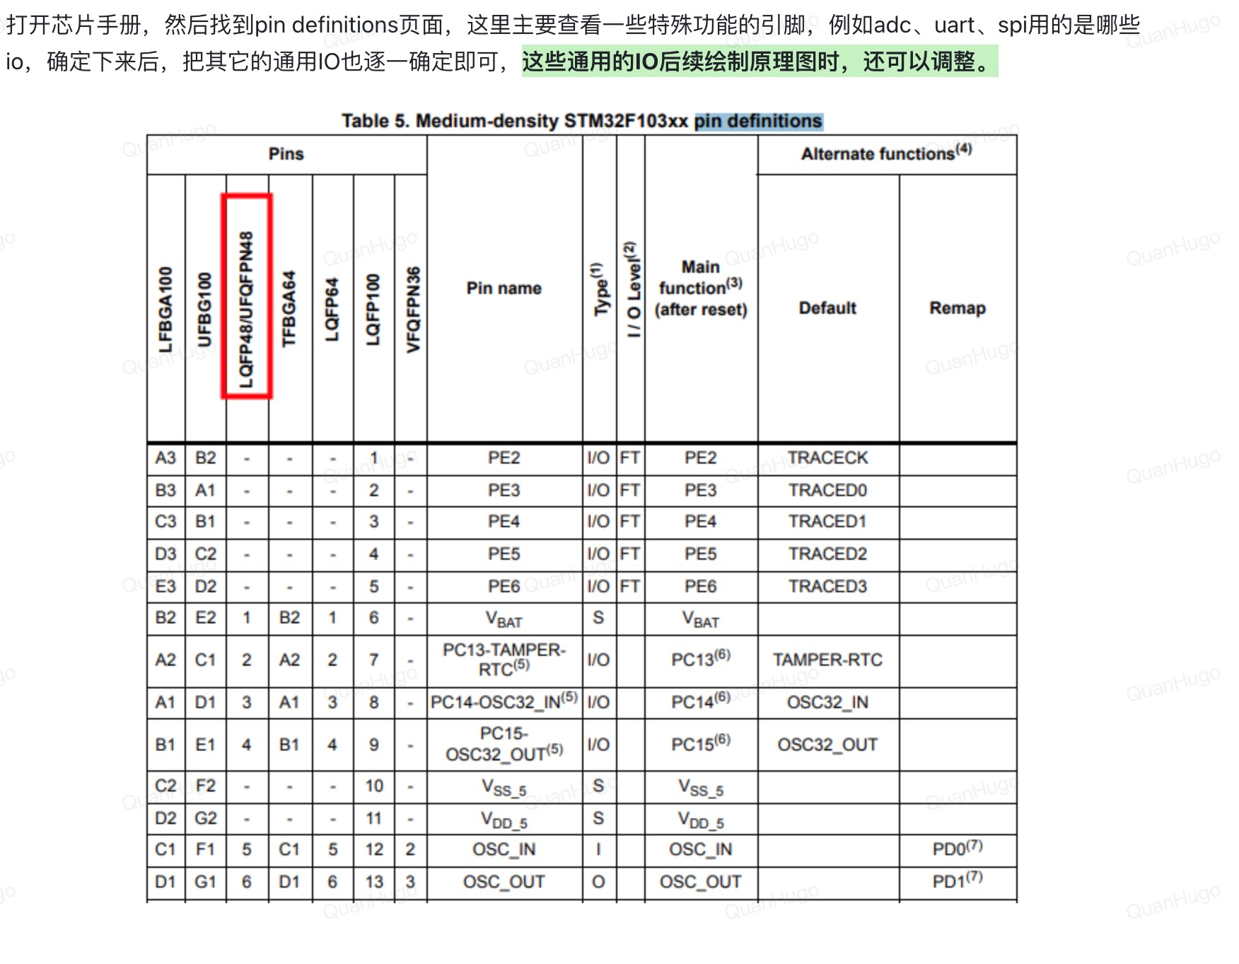

ADC: used for analog to digital conversion

:

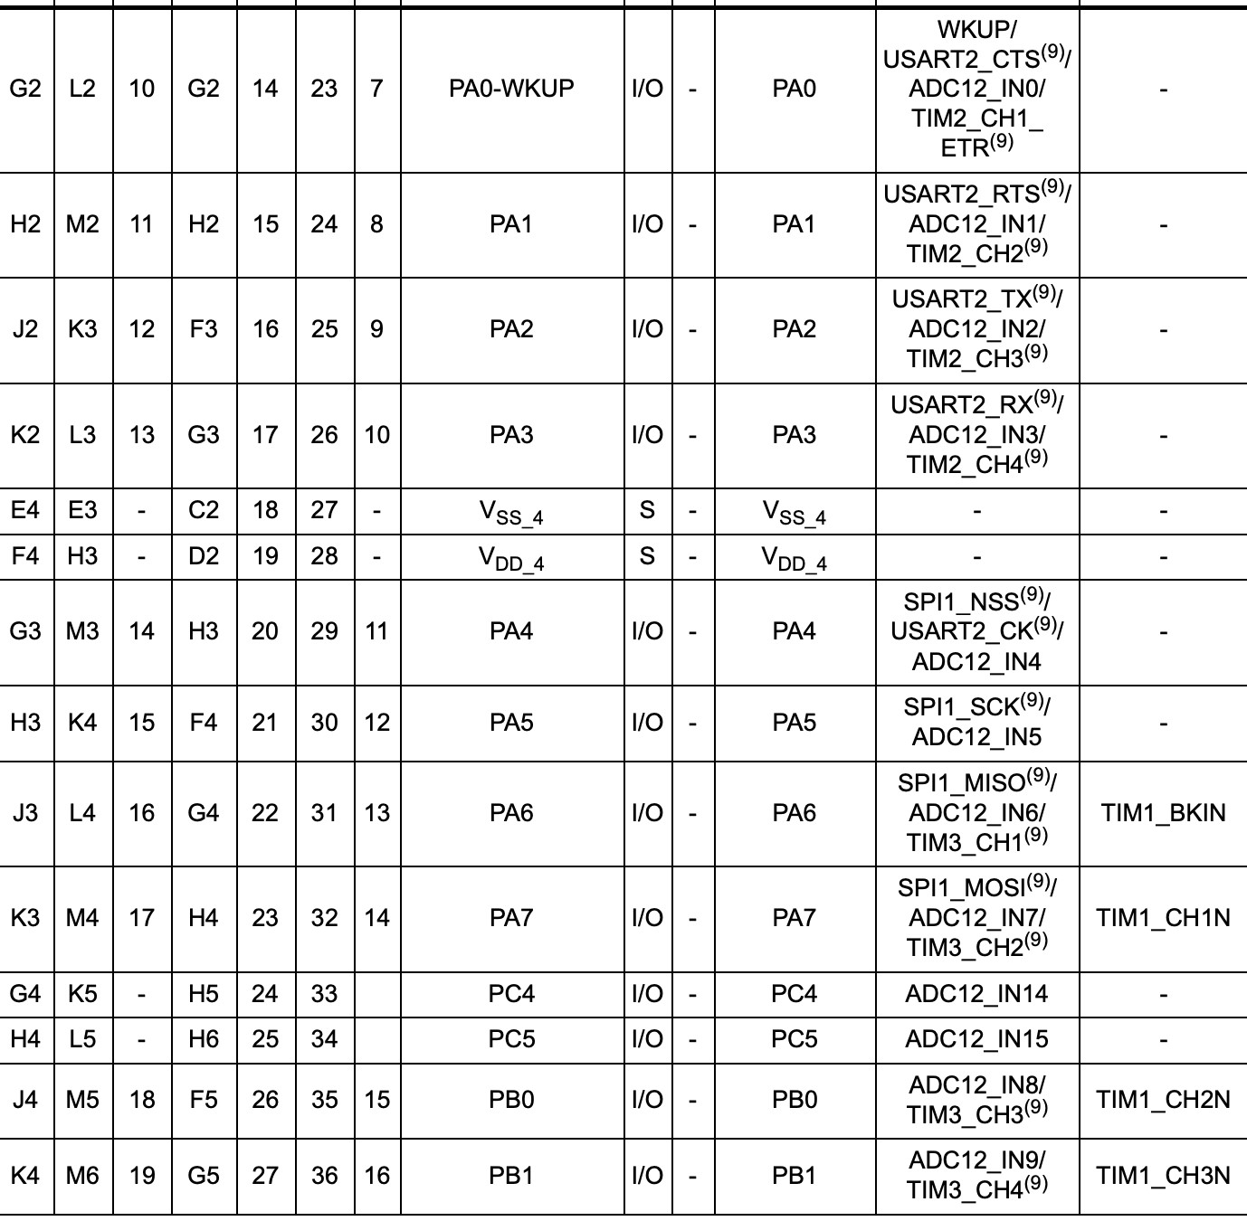

UART: this is used for transmitting and receiving data

Helpful resource: [https://www.totalphase.com/blog/2016/06/spi-vs-uartsimilarities-differences/](https://www.totalphase.com/blog/2016/06/spi-vs-uart-similarities-differences/)

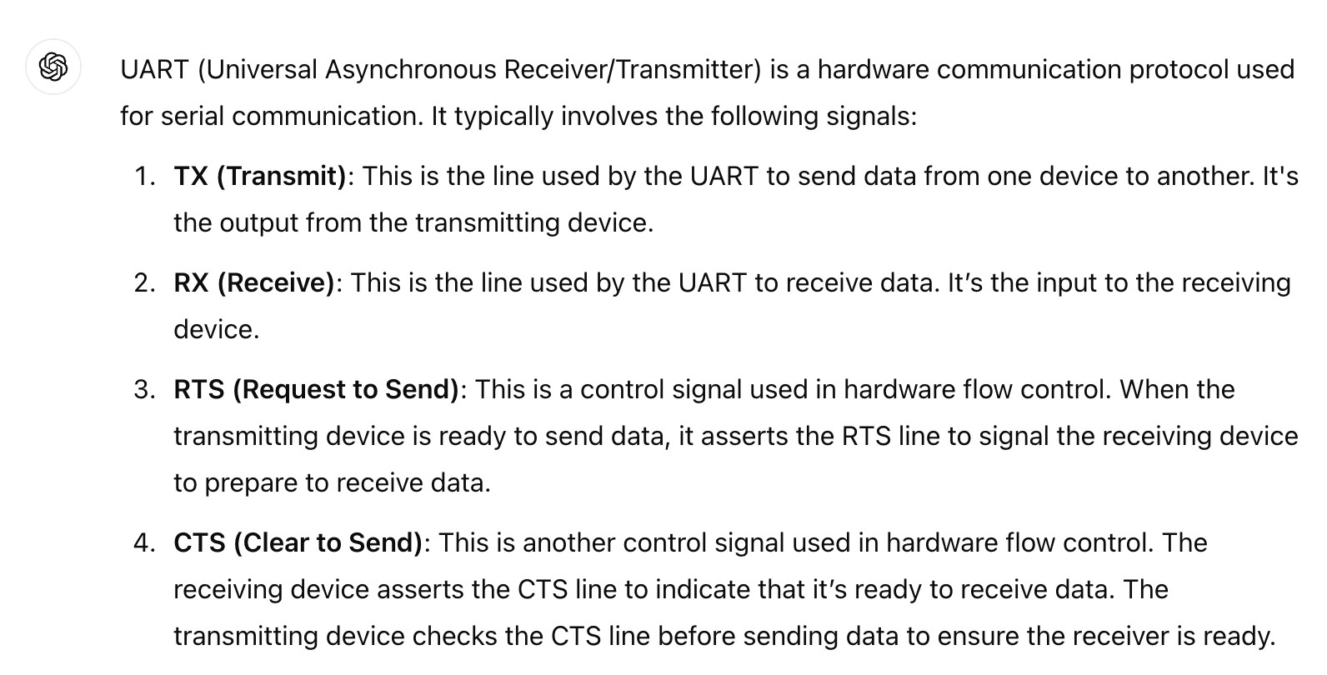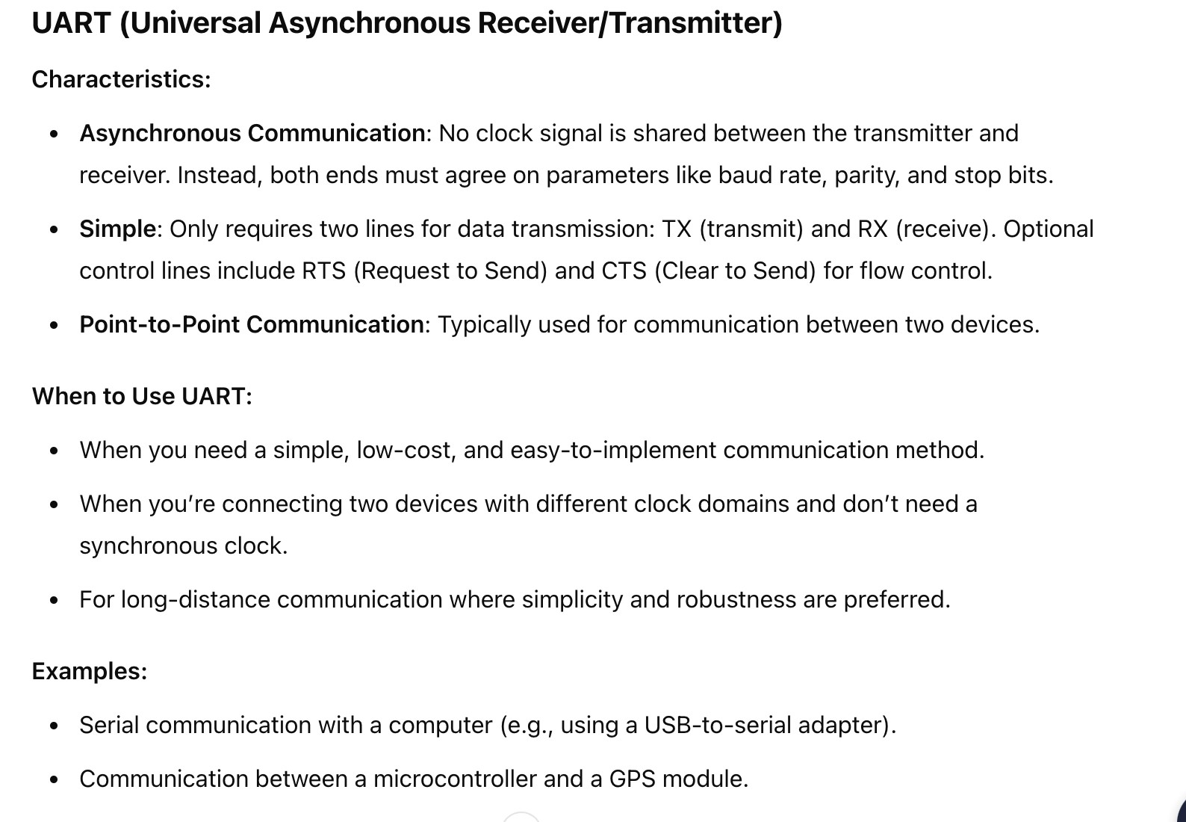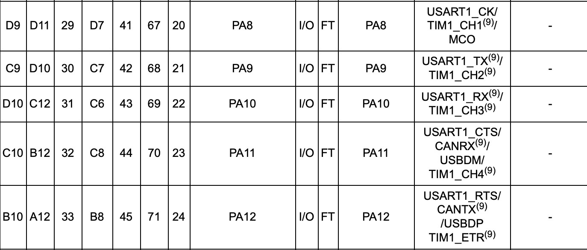

SPI:

Serial Peripheral Interface (SPI) is an interface bus commonly used to send data between microcontrollers and small peripherals such as shift registers, sensors, and SD cards

**外围设置**

:

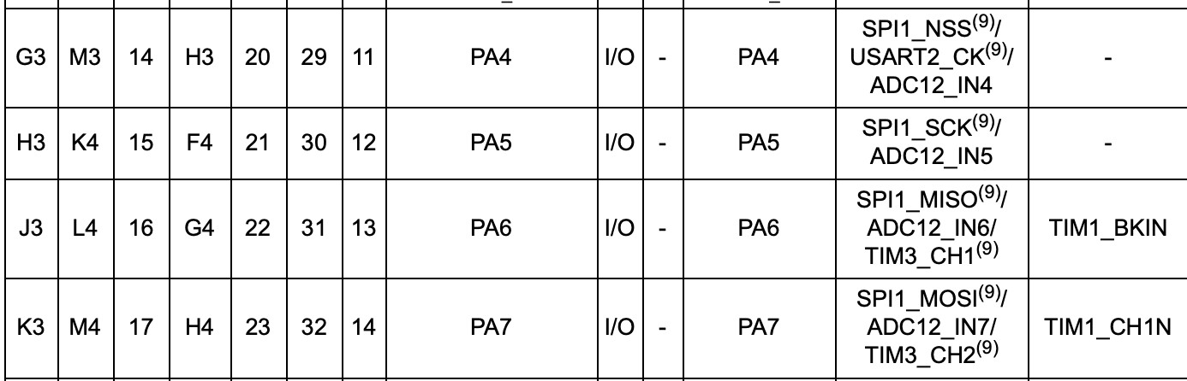

Lithium ion battery data sheet [https://www.lcsc.com/datasheet/](https://www.lcsc.com/datasheet/lcsc_datasheet_2401181411_MICRONE-Nanjing-Micro-One-Elec-ME4054BM5G-N_C478383.pdf)

[lcsc_datasheet_2401181411_MICRONE-Nanjing-Micro-One-Elec-ME4054BM5GN_C478383.pdf](https://www.lcsc.com/datasheet/lcsc_datasheet_2401181411_MICRONE-Nanjing-Micro-One-Elec-ME4054BM5G-N_C478383.pdf)

Mah is milliampere hour, how much charge a battery can hold for hour, like 2000 mah 2000 ma per hour

Wheres Coulomb is how much this battery discharges, a 2000 mah with a 1C discharge rate means it discharges 2000 milliamps in one hour; if it is 2C, it means it discharges 2000 milliamps in half an hour

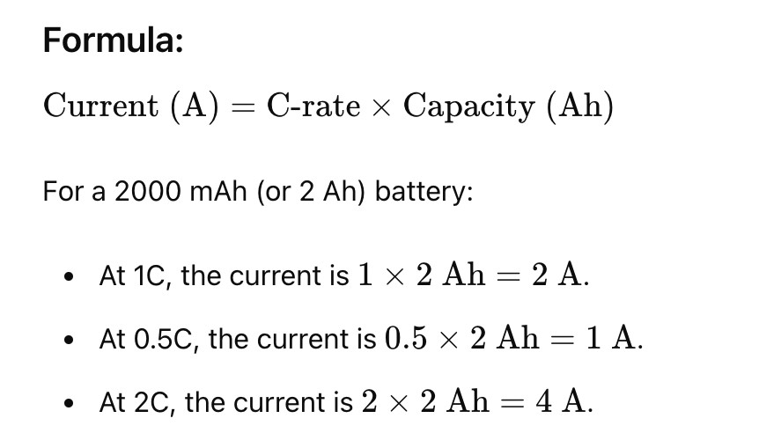

⽽我们需要的printer的current需求要在500mA之内， 2000mah ⽽动⼒电池能达到

10C左右

datasheet写的是4.2V lithium battery

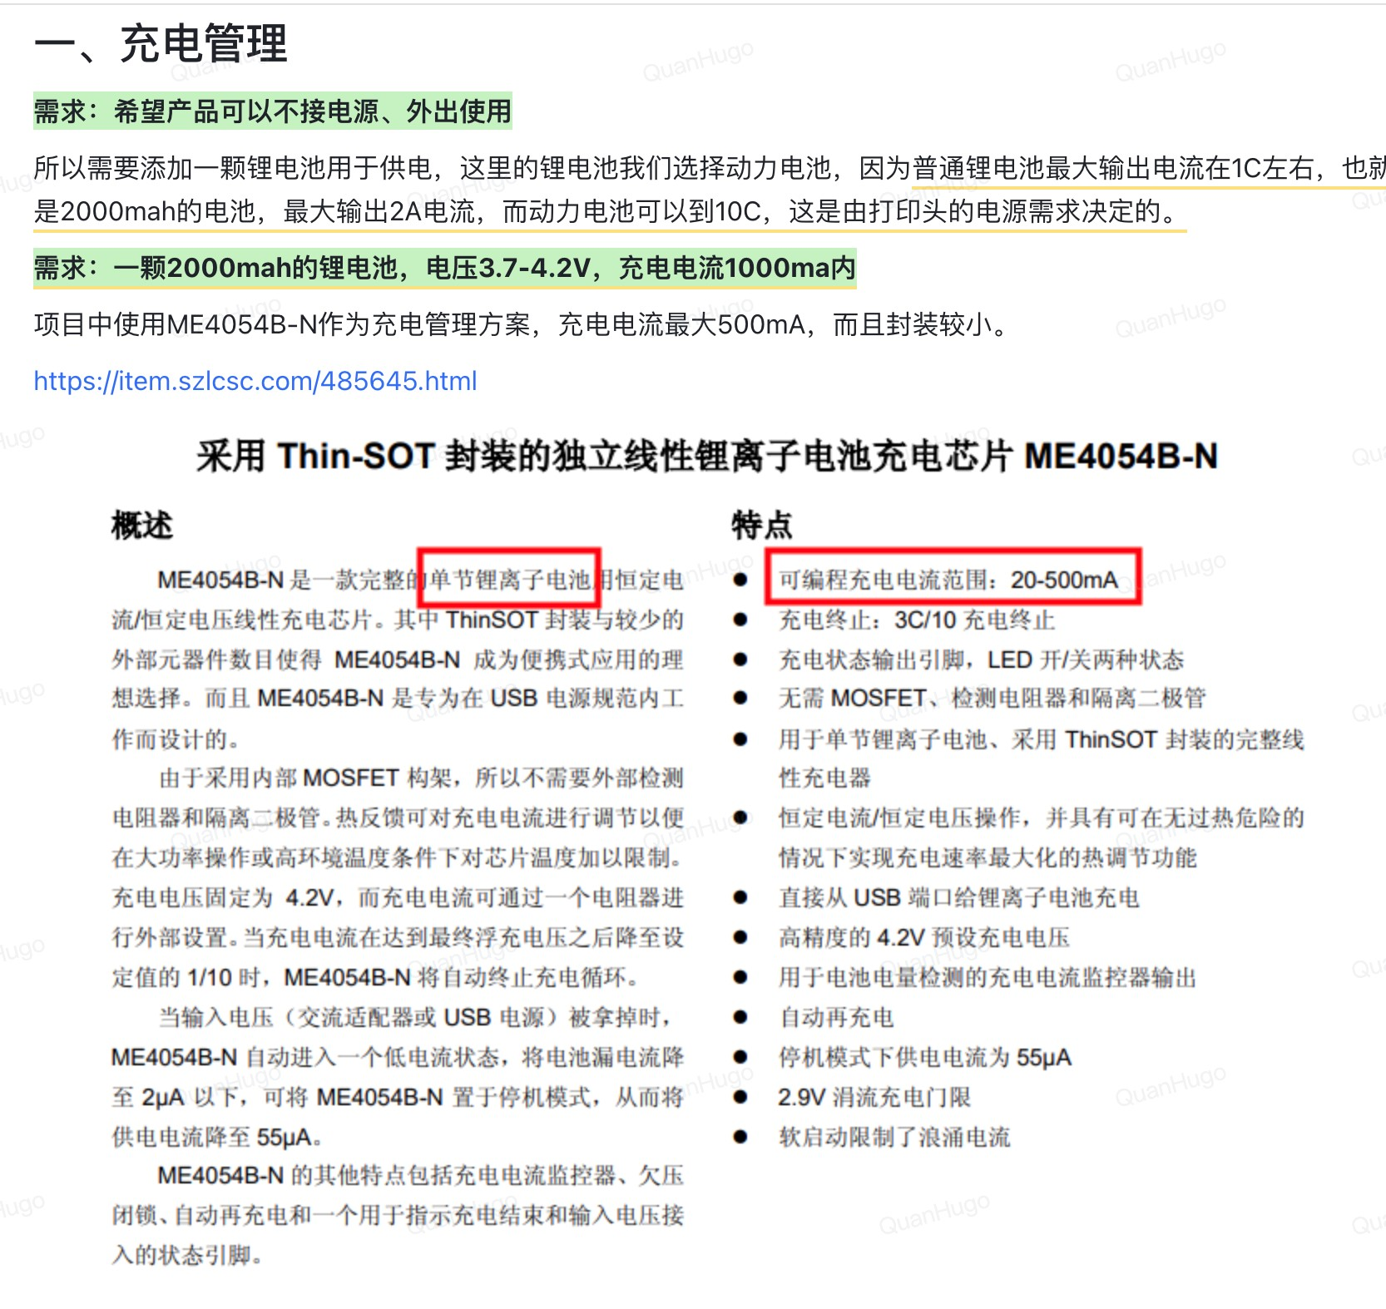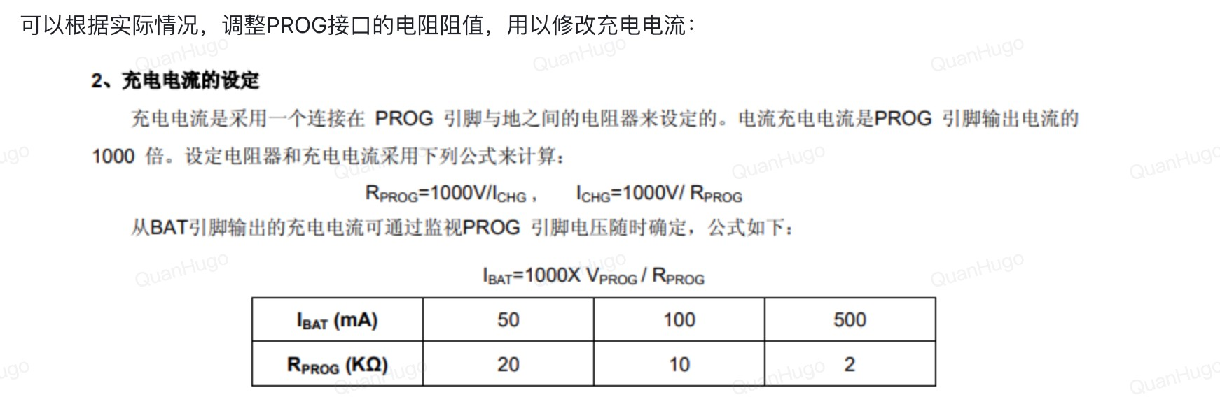

现在可以绘制充电管理的schematics

LED⼀般在10到30mA左右，LED是diode，所以我们可以选择⼀个合适的电阻， resistance来防⽌led破坏

但是datasheet上⾯写了就不⽤我们⾃⼰找了，1k 这个resistor连接到我们的vbus，⽤于usb-c接⼝

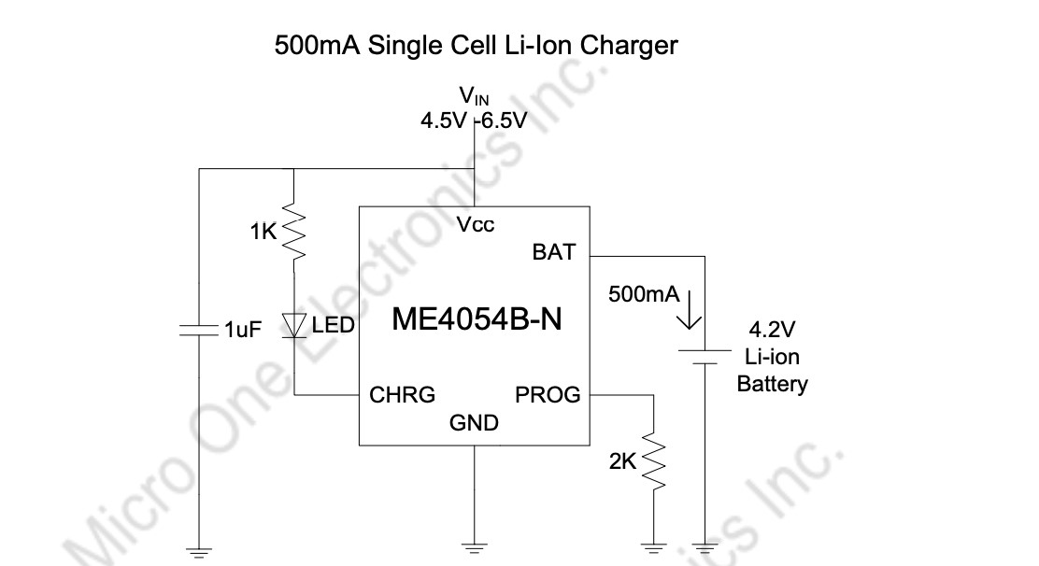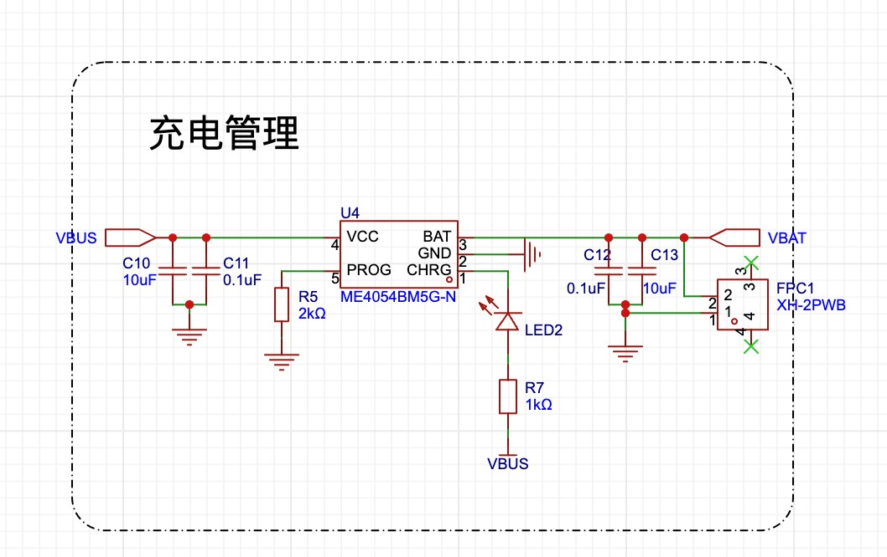

# 下⼀步是： 电源管理（Battery Management)

USBC输⼊电源是5V⽽电脑连接到STM32所需要的是3.3V电压，所以需要绘制转换图，确保不会伤害到芯⽚ 并且是500mA以上的输出电流（current）选择⼀个稳压电路，voltage stablizer选择上其实很flexible，只要达到⽬的就好并不需

要独特的

我们选择的是这个： <https://item.szlcsc.com/418424.html>

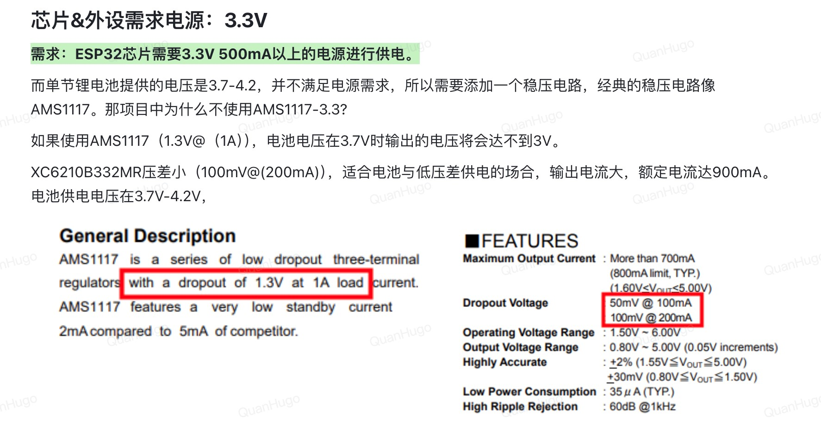

我们不⽤AMS1117是因为他的压差很⼤，3.7V的时候压差就不够3.3V了，所以我们需

要⼀个压差⼩⼀点的Voltage Stableizer

**电量检测**

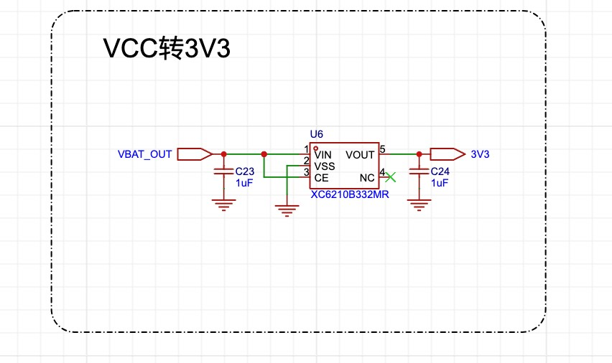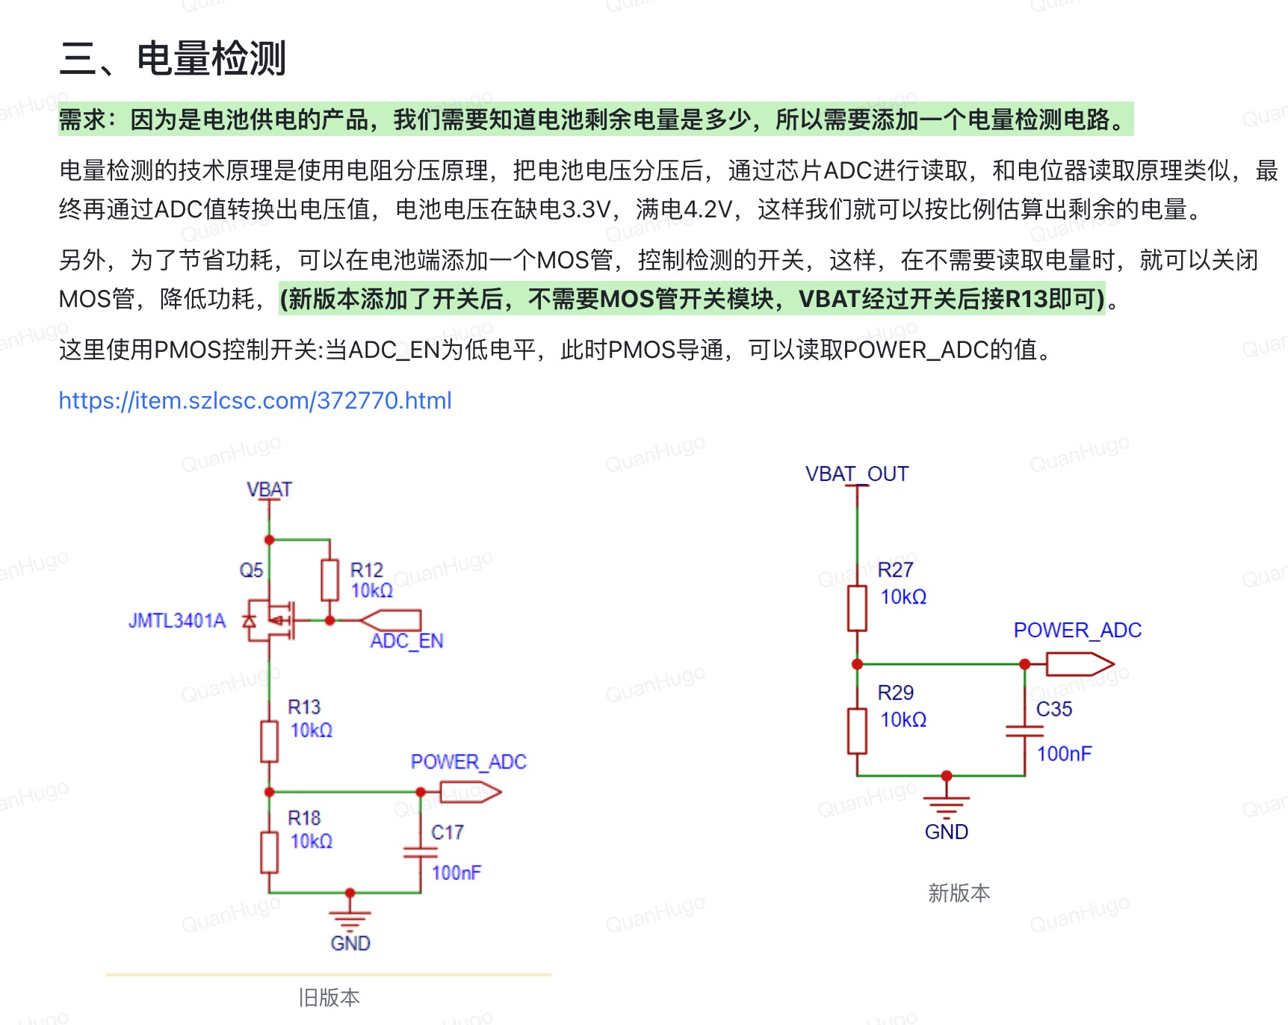

其实这⾥使⽤的是P mosfet的原理， when the battery is 3.7V, which is low battery voltage, the P Mos opens up the gate, allowing voltage to pass through and checks the battery through the POWER_ADC and the voltage divider across two same resistors and detect it through power)ADC, which is analog to digital signal, cuss voltage is analog signal, and STM32 uses digital signal

The extra Pmos is used for when battery is full, we don’t want it working and wasting power, so we use that to cut off the power, and it just acts as a gate

We don’t actually need the extra Pmos because we do have a specific switch for opening and closing; thus, battery goes through the switch then the battery detection

The extra resistor, R12 sets the operating point for gate detection

**按键**

LED:

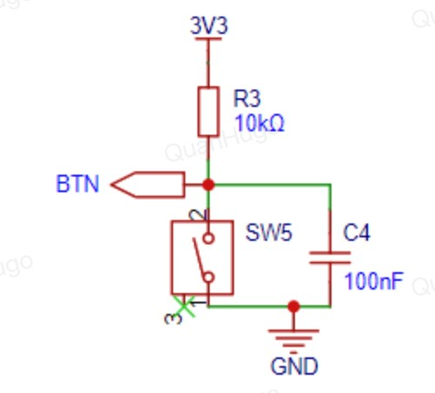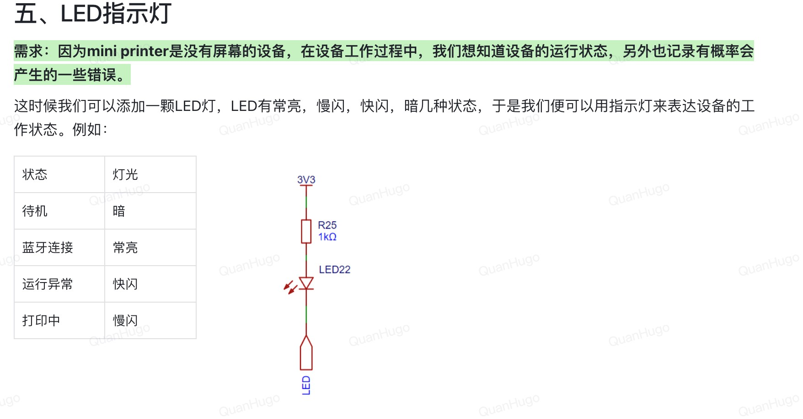

LED is diode, so we just pick the appropriate resistor

Comes from 3v3 because it is after we stabilize the battery voltage to provide voltage to the LED

# 打印模组绘制

需要找⼀个打印头，打印头是有电机，热敏头，传感器,还有fpc

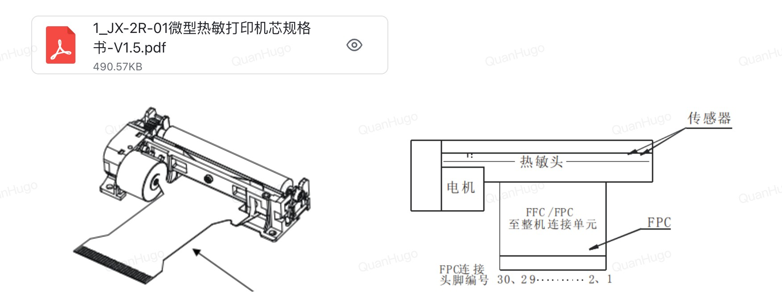

# 打印模组绘制

打印的时候需要热敏电阻驱动，因为打印的时候过热的话会导致出问题，所以我们可以通过Thermistor去做温度检测

通过打印头的

datasheet

确认

IO

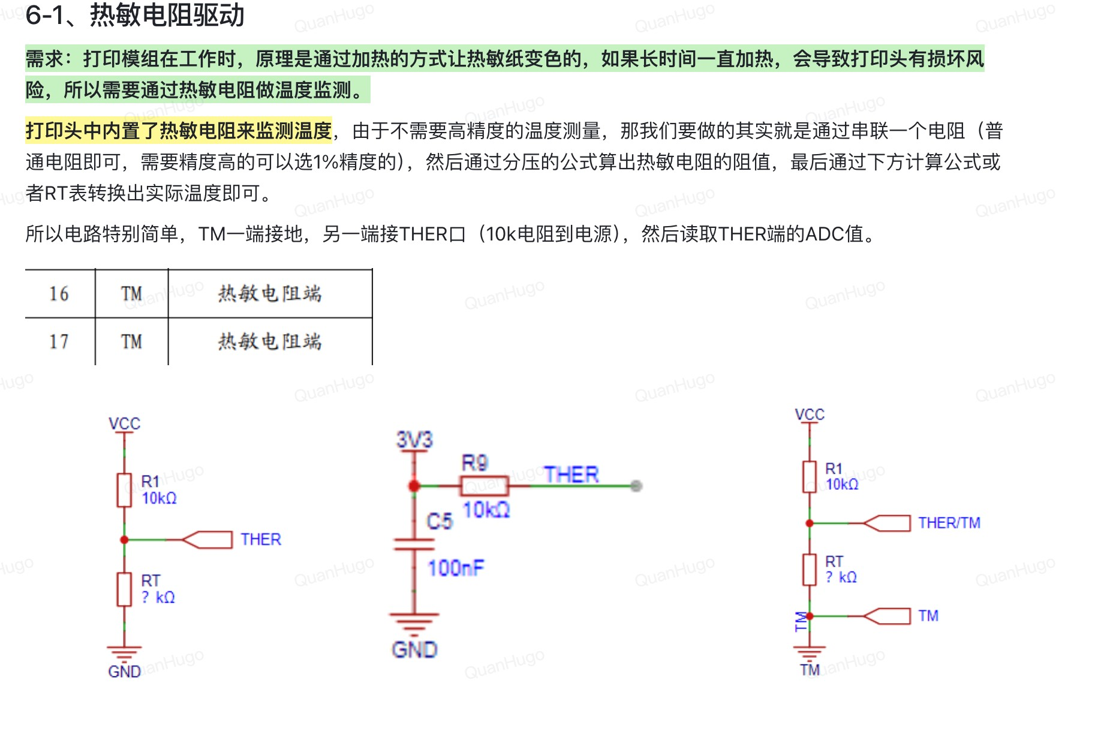

中间的是热敏电阻的电路图， 加了⼀个filter去过滤掉嘈杂的频率，左边图⾥的RT就是热敏电阻，通过分压来就算出阻值，右边的图就是加上TM的两端，和左边的图⼀样

THER连到芯⽚

TM TM from 打印头datasheet 连接到打印头的schematics THER还有GND **缺纸检测**

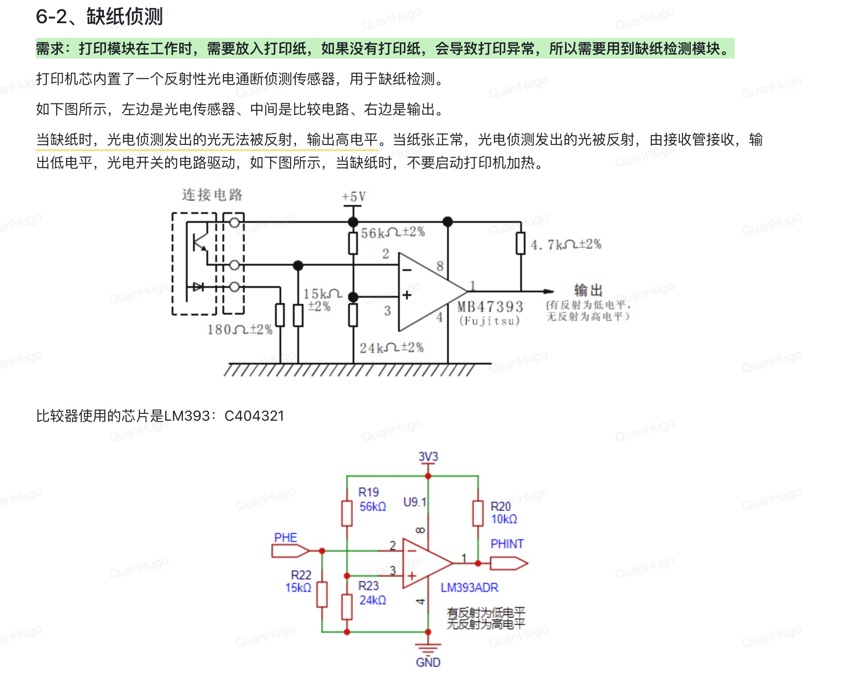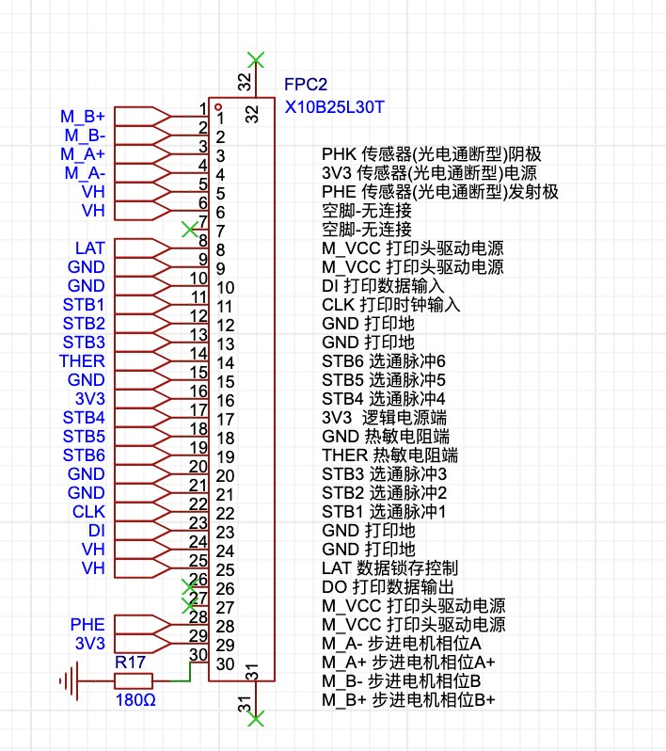

The knowledge here uses a comparator to test the missing of papers,

输出到我们的芯⽚⾥⾯通过芯⽚来读这个传感器， 然⽽PHE是连接到我们的打印头那

⾥的

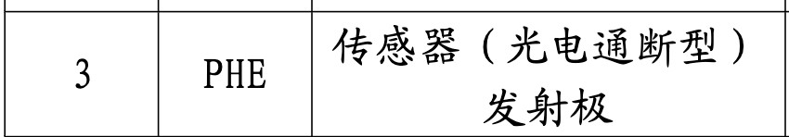

还有GND，就是阴极，还有电源都得连接到打印头的schematics那⾥

GND

需要⼀个

180

Ohm

的地

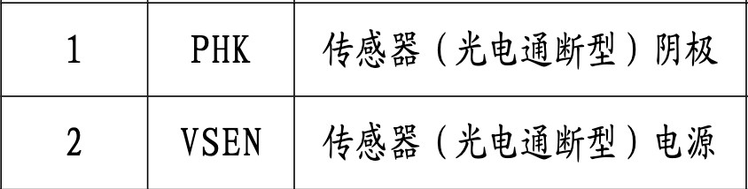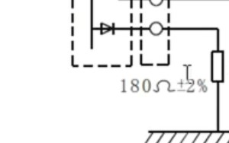

# 电机

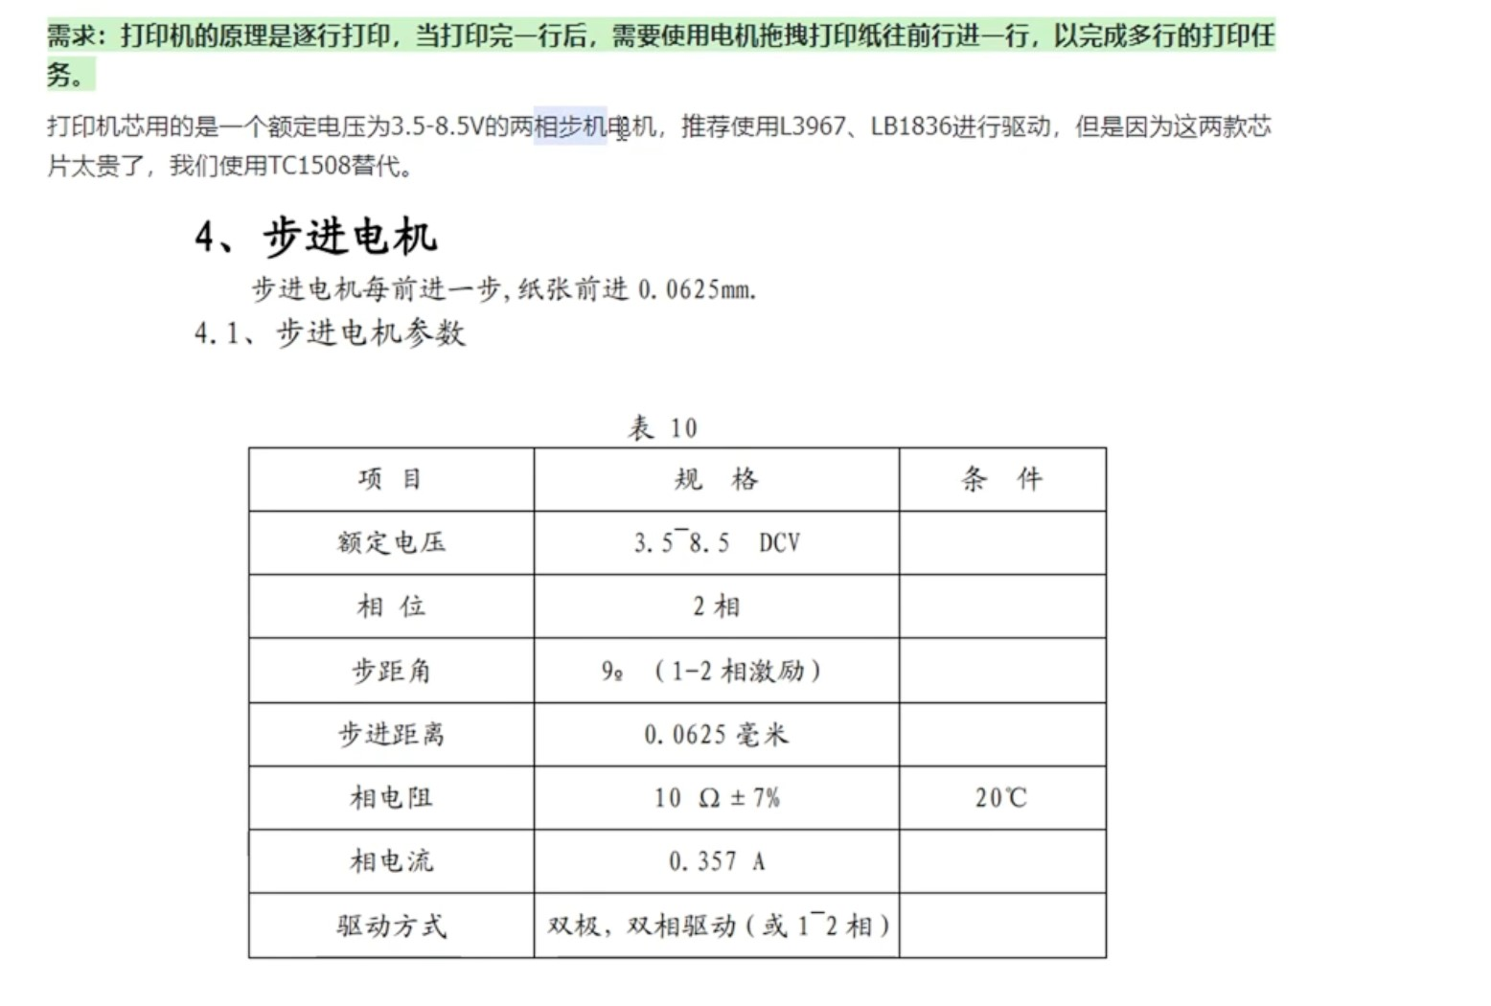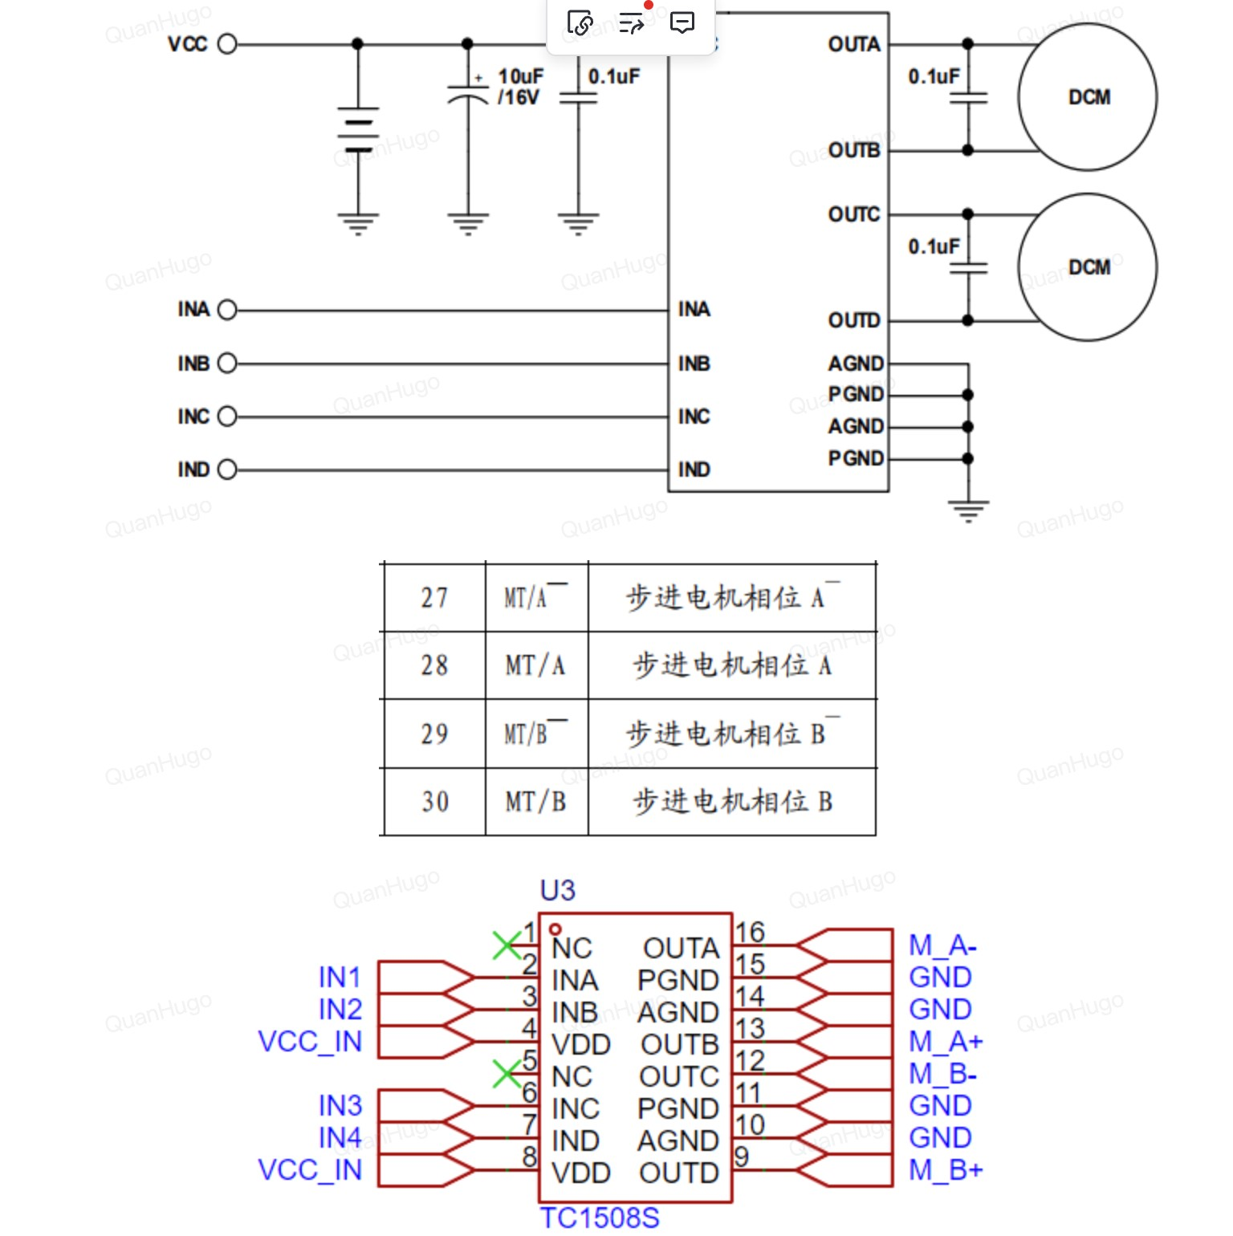

M_A+-， M_B+- 对应的是打印级datasheet打印头⾥⾯的27,28,29,30 INABCD就是对应IN1234，这些是IO⾥⾯的IN1234

剩下的打印头接⼝就是通过VH，STB的接⼝来

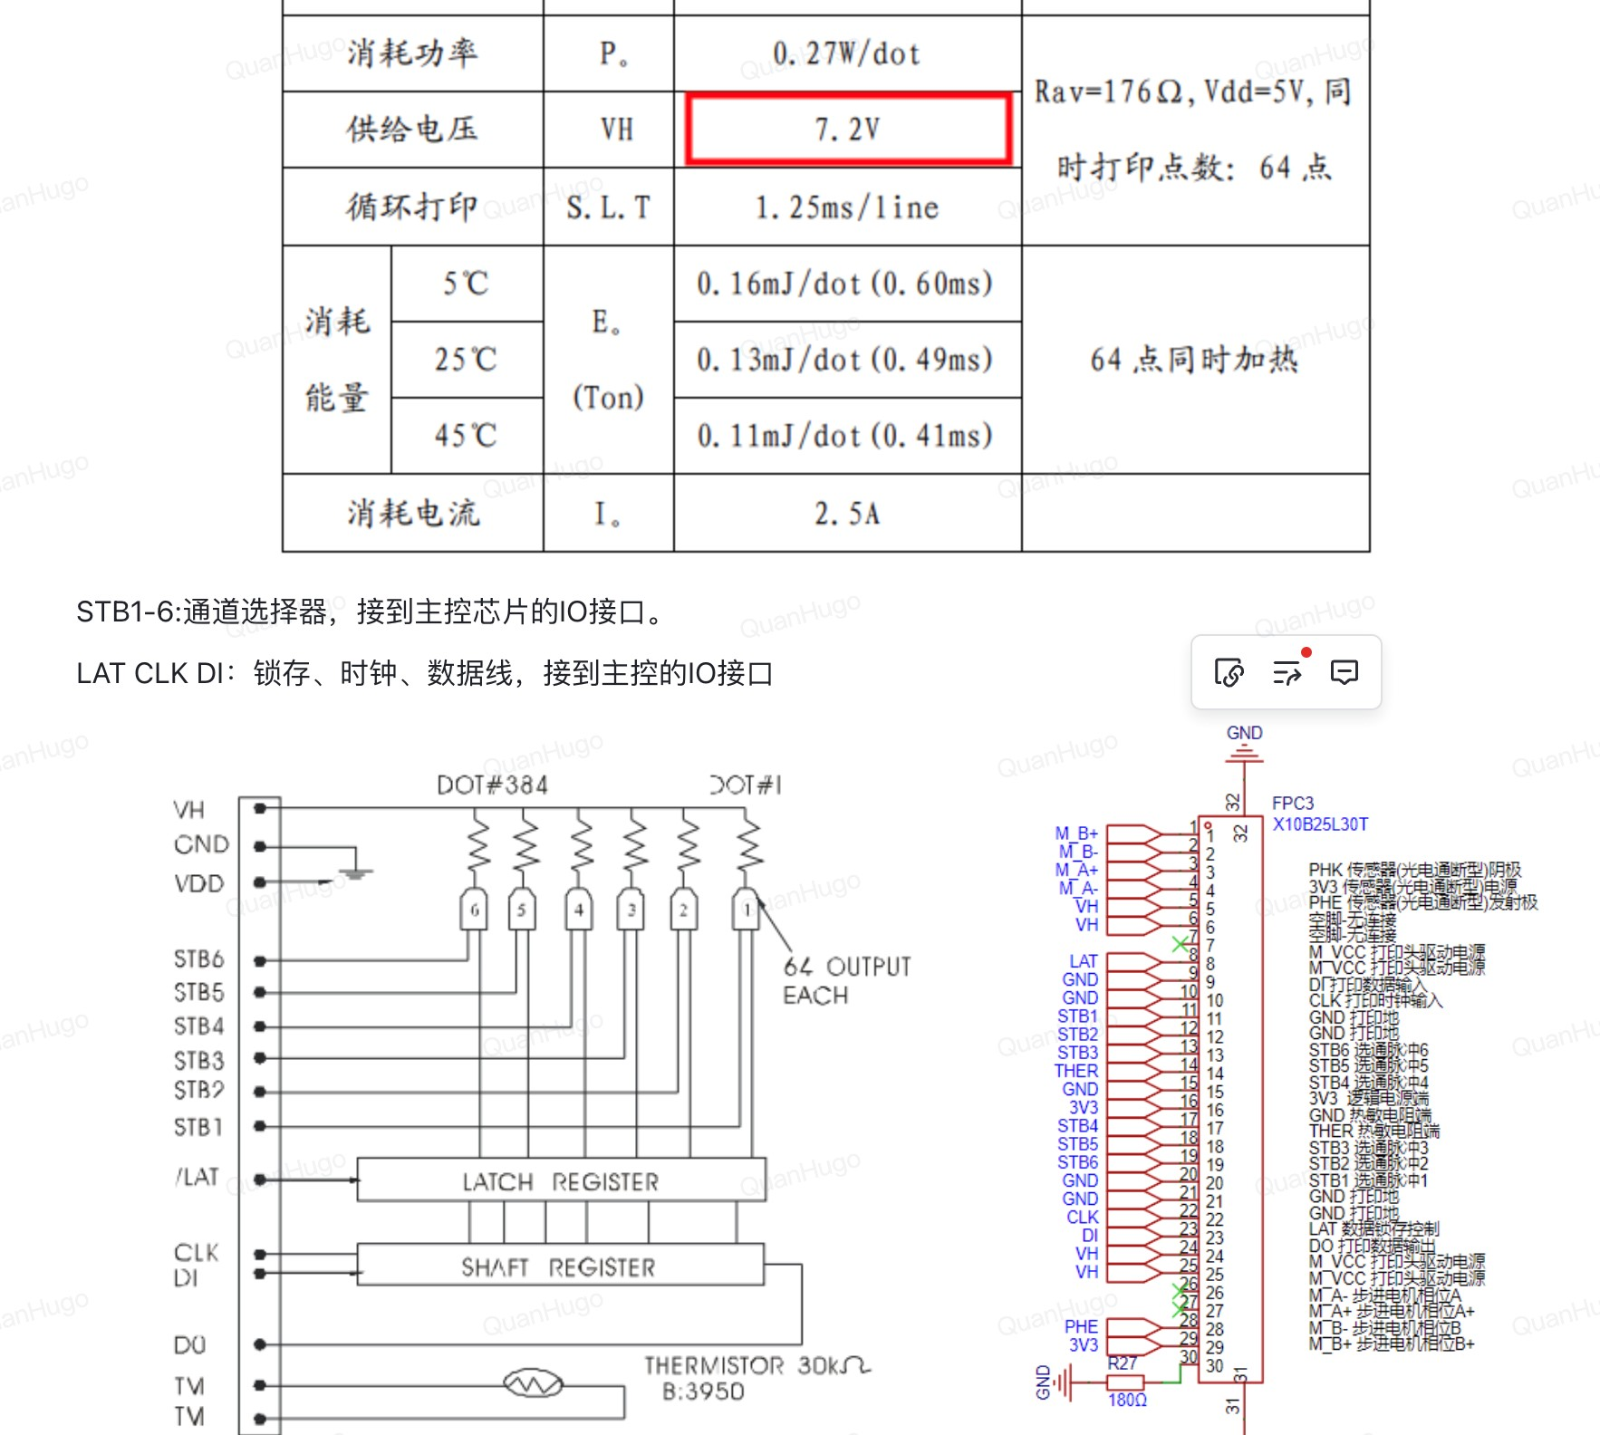

The clk sends the data based on certain frequencies, to the shaft register, then they can sent to the latch register, where it will hold it’s input until everything is sent and ready to go, then the latch register will send out all the 384 dots for printing

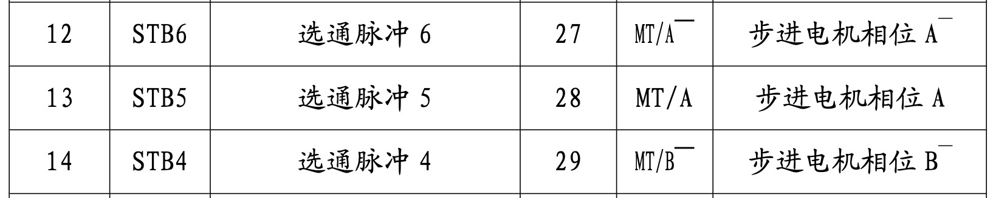

Vh is 7.2V 得转升压

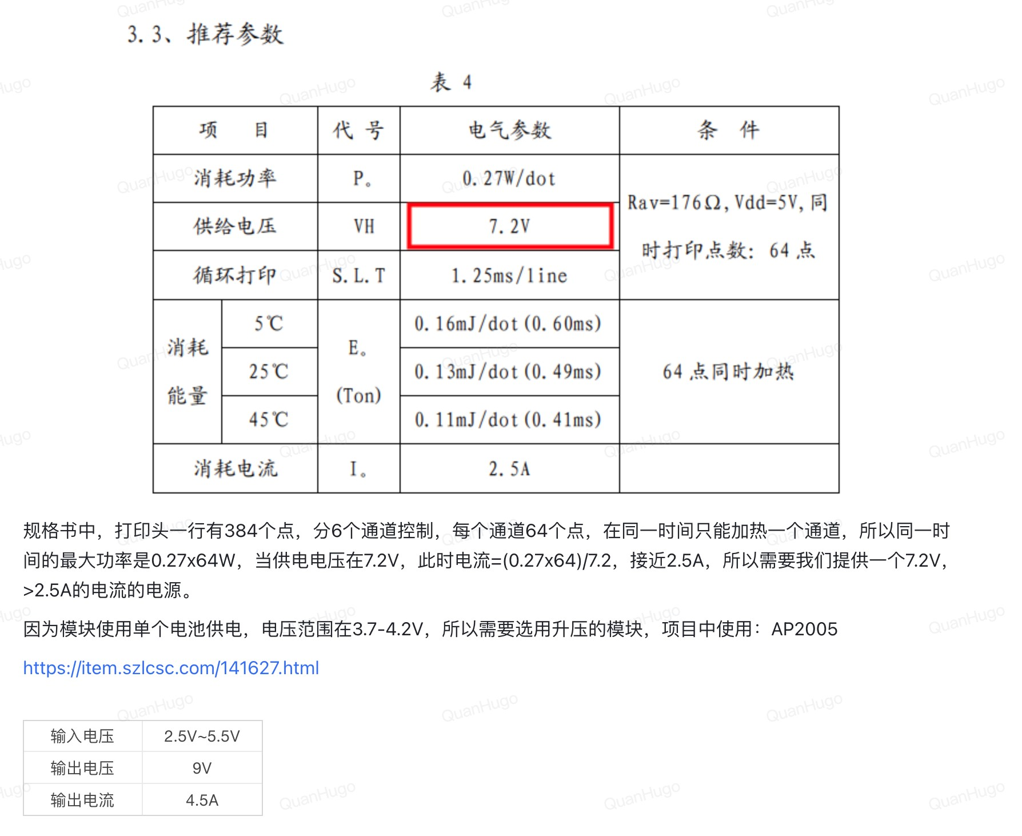

输出电压可达到9V可调节，⽽输出电流则是通过64点每个通道x0.27w每个点除于7.2V 最⼤电压来看看输出最⼤电流要多少 input is



STM32 的供电在2V到3.6V，所以我们可以直接使⽤电池供电

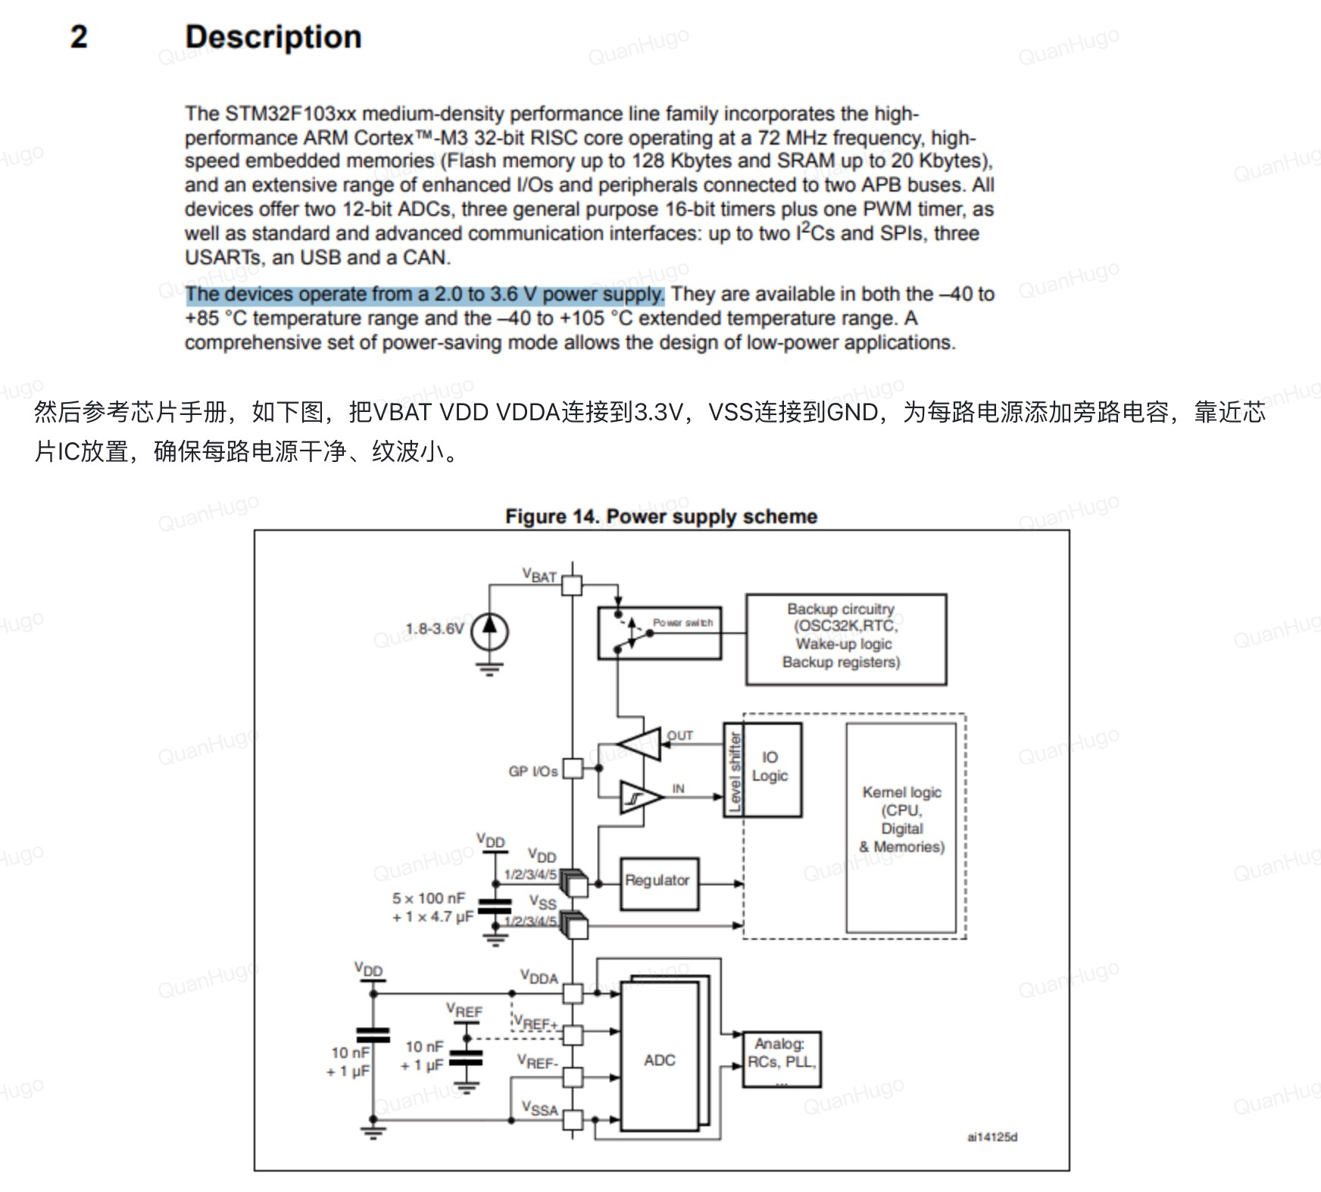

VBAT ， VDD，VDDA，FROM 芯⽚ 到3.3V

VSS 到GND

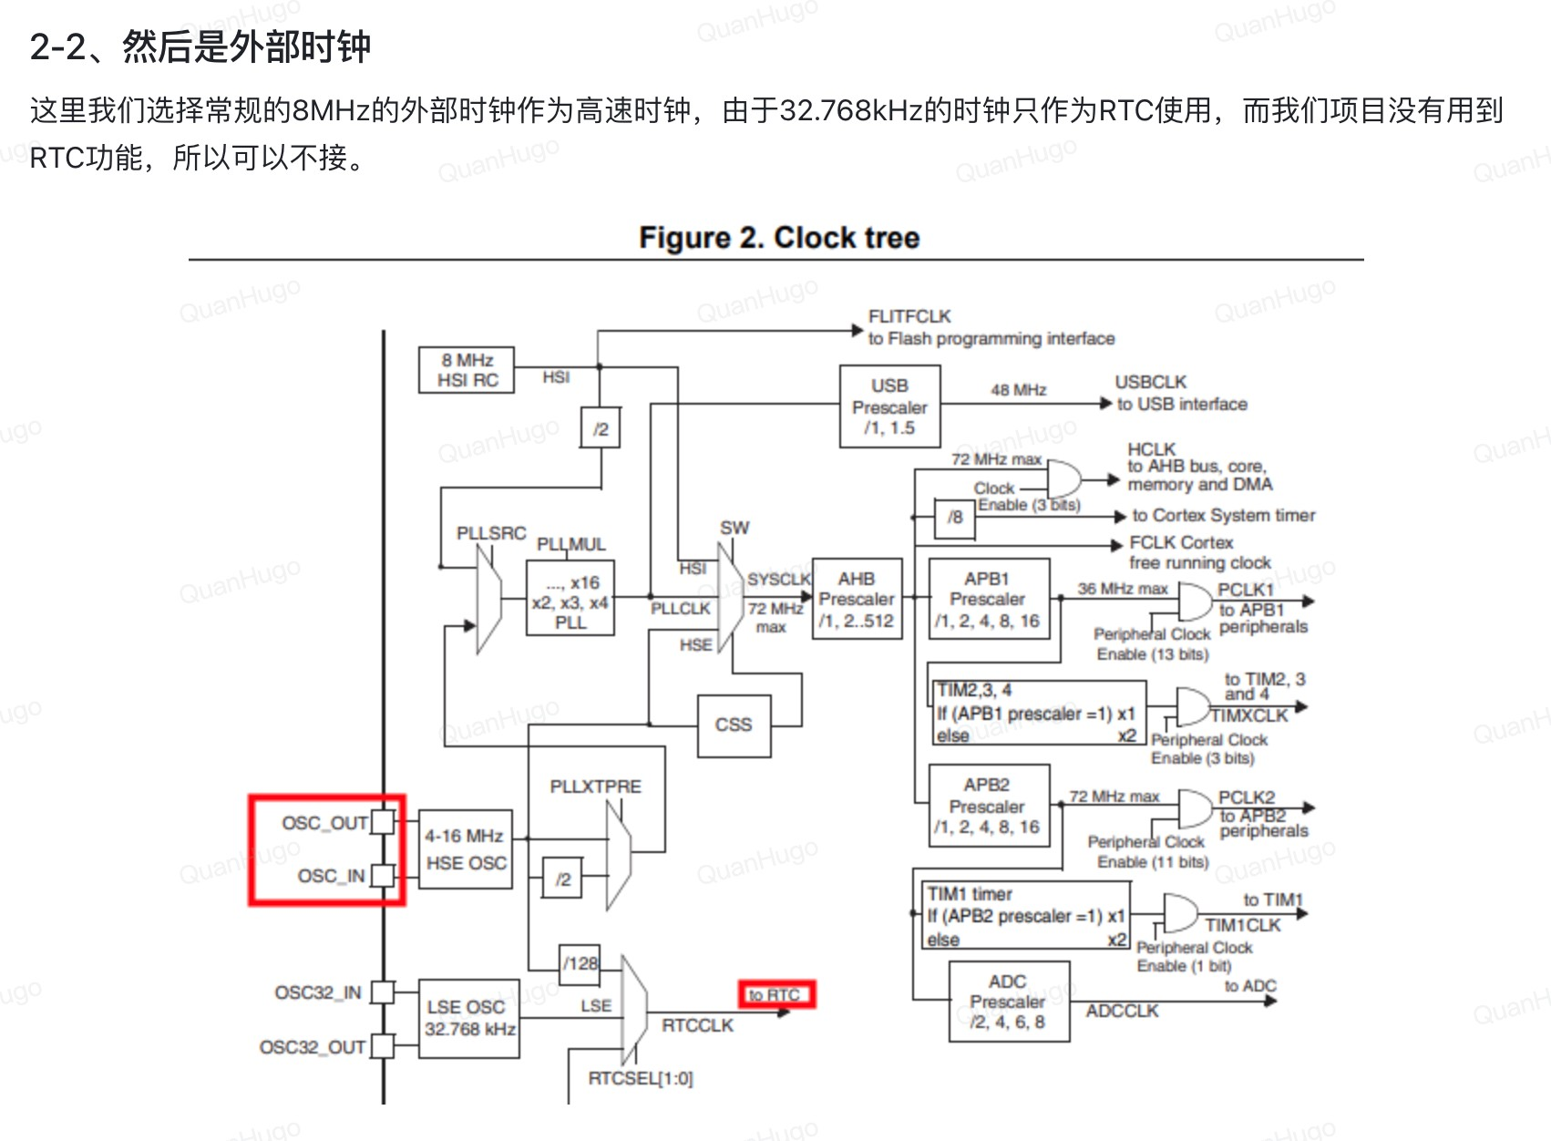

A real time clock, or RTC, is a digital clock with a primary function to keep accurate track of time even when a power supply is turned off or a device is placed in low power mode.What is a Real Time Clock (RTC)? A real time clock, or RTC, is a digital clock with a primary function to keep accurate track of time even when a power supply is turned off or a device is placed in low power mode.

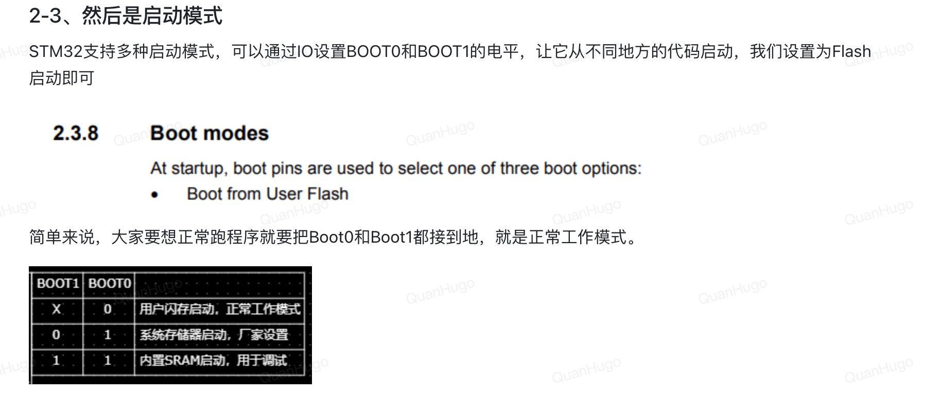

Use two 10k resistors to serve as a pull down resistors to keep the pins of boot0 and boot1 at a low logic level, so when they are not used, no other voltage can pass through it

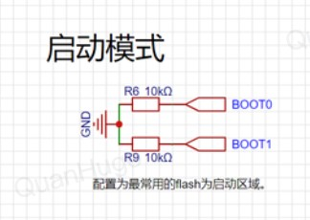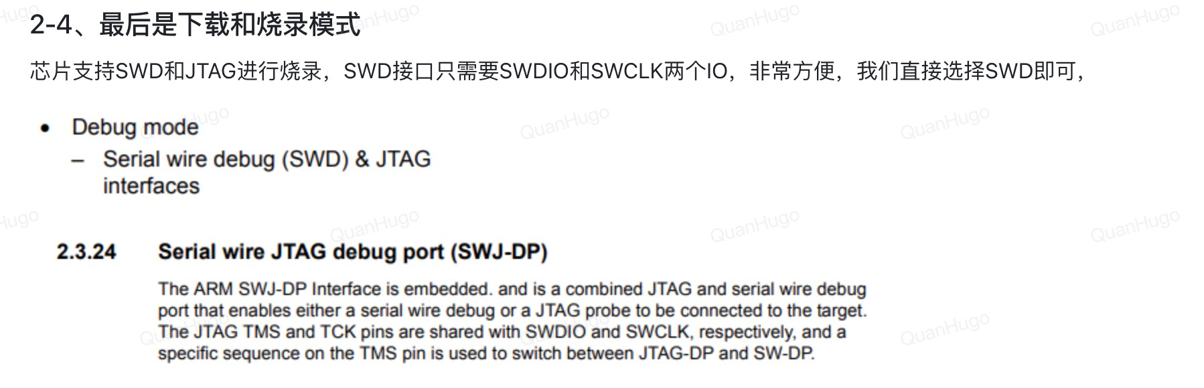

烧录就是程序员写好的程序，把程序导⼊到⽬标IC上⾯，实⾏⼀个完整的动作。

我们使⽤SWD的话就可以直接把SWDIO还有SWCLK两个IO连接到芯⽚上⾯:

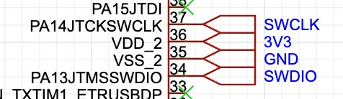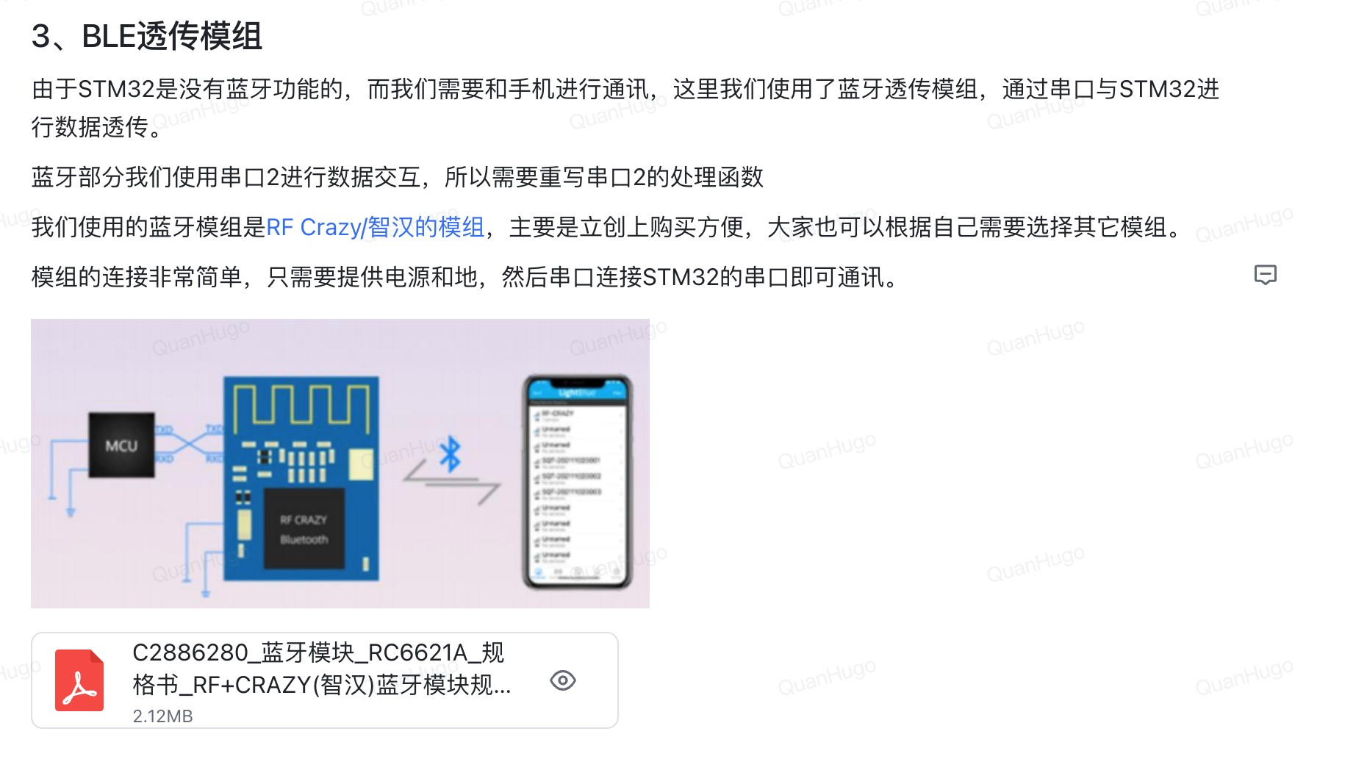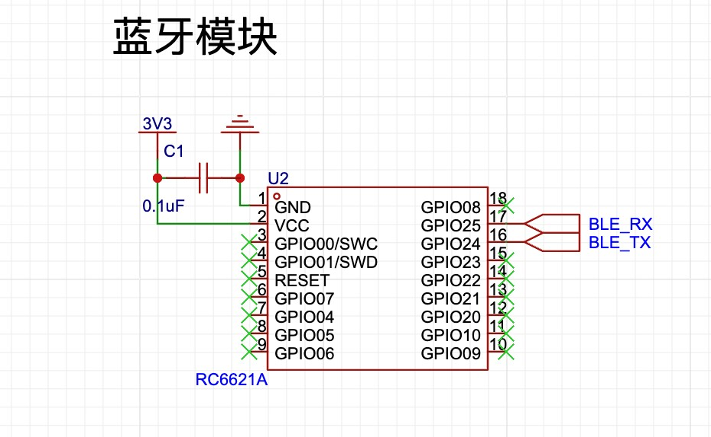

The capacitor is for bypassing and filtering frequencies that are high before reaching to the bluetooth module

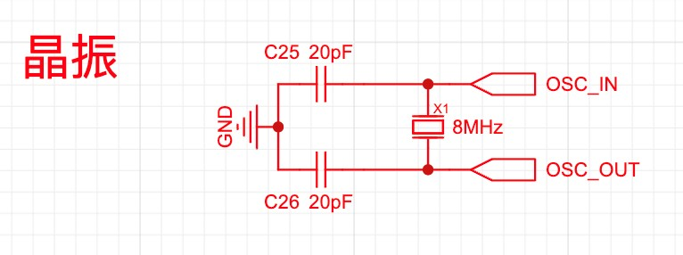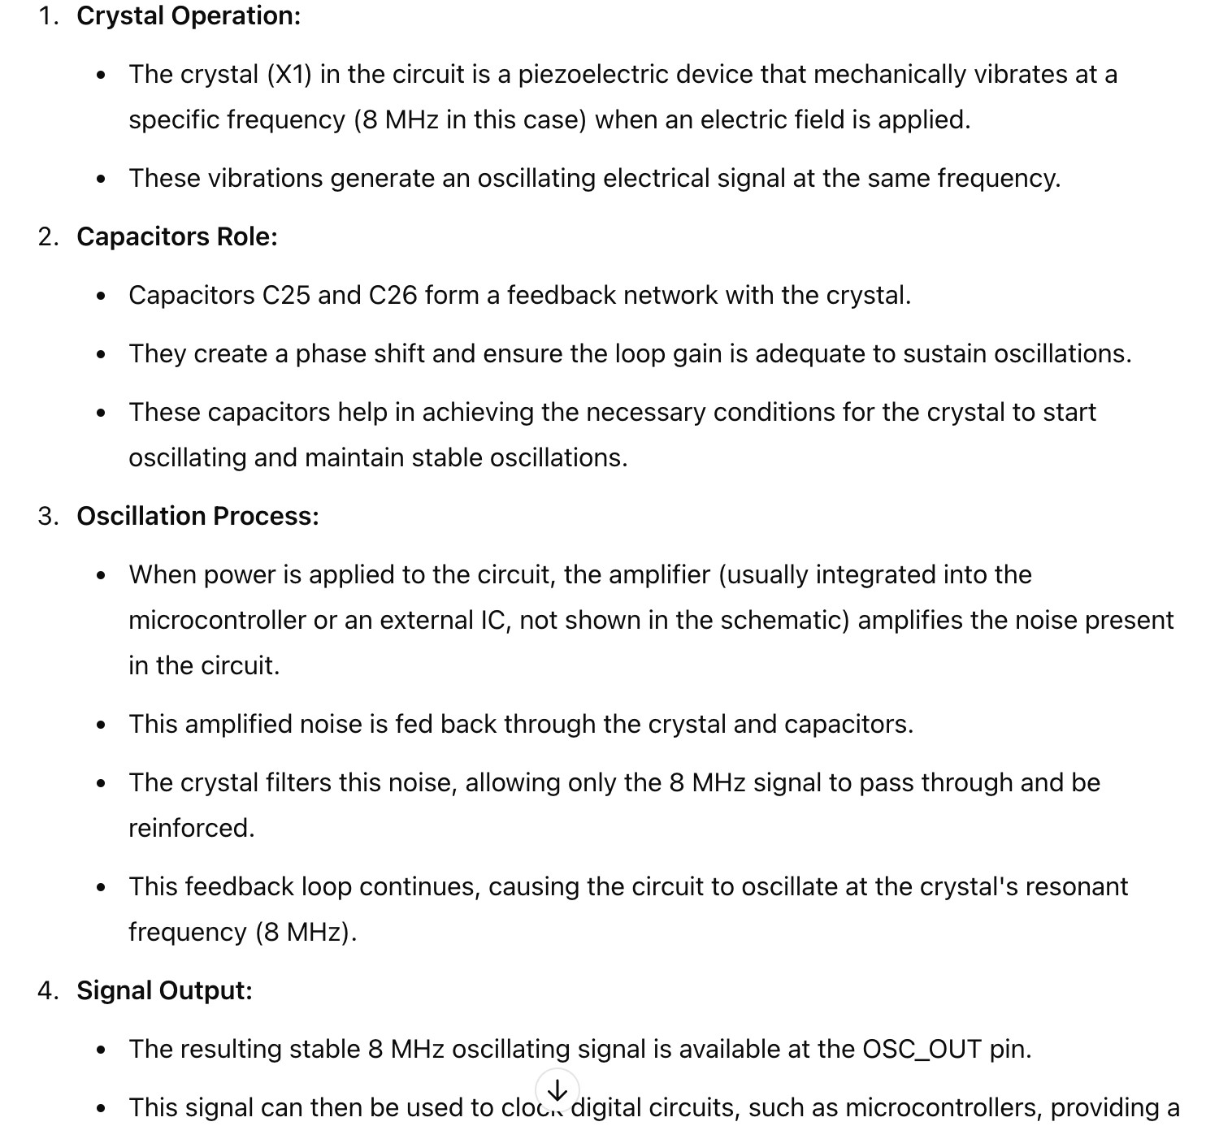

At low frequency, it allows only 8MHZ frequency to pass through and at high frequencies, they are filtered out through the filters from capacitors. And 20pF is used because for a 8MHZ it is usually between 18 to 22 pF

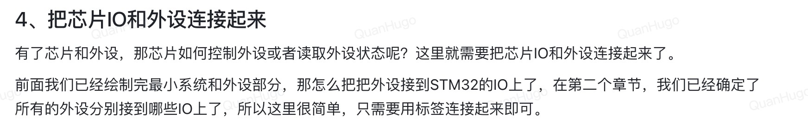

我们可以先list out所有的IO然后通过这个list来连接到我们的芯⽚上⾯：

## Power and Ground Connections

1. VBAT (Pin 1): Connected to a 3V3 supply. This pin powers the RTC and backup registers when VDD is not present.
2. VSS_A (Pin 8), VSS_1 (Pin 23), VSS_2 (Pin 35), VSS_3 (Pin 47): Connected to GND. These are ground pins.
3. VDD_A (Pin 9), VDD_1 (Pin 24), VDD_2 (Pin 34), VDD_3 (Pin 48): Connected to 3V3. These are the main power supply pins for the microcontroller.

## Clock Pins

1. OSC_IN (Pin 5), OSC_OUT (Pin 6): Connected to the external crystal oscillator. These are necessary for providing a clock signal to the MCU.
2. PD0-OSC_IN (Pin 4), PD1-OSC_OUT (Pin 5): These are for an optional secondary clock, often a 32.768 kHz crystal for RTC.

## Reset and Boot Pins

1. NRST (Pin 7): Connected to a reset button. This pin resets the MCU when pulled low.
2. BOOT0 (Pin 44): Connected to a switch or jumper. This pin determines the boot mode of the MCU.

## Peripheral Pins

1. USART (Pins 12, 13, 14):
   1. PA9/PA10: UART1 TX and RX for serial communication. ○ PA2/PA3: UART2 TX and RX for serial communication.
2. SPI (Pins 15, 16, 17, 18, 19, 21):
   1. PA5, PA6, PA7: SPI1 SCK, MISO, MOSI for SPI communication.
3. I2C (Pins 27, 28):
   1. PB6, PB7: I2C1 SCL and SDA for I2C communication.
4. ADC (Various Pins):
   1. PA0, PA1: Analog input for ADC.

○ PB0, PB1: Additional analog inputs.

1. PWM/Timer (Various Pins):
   1. PA8, PA9: Timer channels for PWM output.
2. General GPIO:
   1. Various other pins like PB12, PB13, etc., are used as general-purpose

IO pins for connecting LEDs, buttons, etc. Connectivity Pins

1. SWD (Pins 36, 38, 37, 32):
   1. PA13, PA14, PB3: Used for programming and debugging the MCU.
2. Other Interfaces:
   1. CH340_RX, CH340_TX (Pins 30, 31): These are for UART to USB communication via CH340 IC.

## Possible Reassignments

Most IOs on the STM32 can be remapped to different pins using the alternate function remap registers. However, some pins have fixed functions:

* Power and Ground: Cannot be changed.
* OSC and NRST: Generally should not be changed for stability.
* BOOT0: Should remain fixed for reliable booting.

For other peripherals, you can change their connections depending on your application and PCB layout, as long as the chosen pins support the desired function.

Summary

* Power/GND, Clock, and Reset pins are generally fixed.
* Peripheral pins can often be remapped to different IOs using the MCU's remapping capabilities.
* Some pins like BOOT0, SWD, and primary oscillator pins should remain as recommended for proper operation.

Actul Connection:

POWER and GND:

3v3 to VBAT, VDD, VDDA

GND to VSS

VBATOUT， battery output is not connected to the STM32 as

CLOCK-PINS:

OSC_IN and OCS_OUT connect to OSC_IN (Pin 5), OSC_OUT (Pin 6)

Reset and Boot Pins:

NRST (Pin 7): Connected to a reset button. This pin resets the MCU when pulled low.

BOOT0 (Pin 44): Connected to a switch or jumper. This pin determines the boot mode of the MCU.

Peripherals: peripheral pins can usually be remapped depending on the STM32’s requirements

IN1234 is from 电机驱动，uses GPIO pins

## Timer Pins and Motor Control

1. Pulse Width Modulation (PWM):
   1. Motor speed and direction are often controlled using PWM signals.

○ Timers in the STM32 microcontroller can generate PWM signals, which are used to control the duty cycle of the motor's power input, thereby adjusting its speed.

1. Precise Timing Control:
   1. Timers allow for precise control over the timing of signals, which is crucial for motor control applications.

○ Using timers, you can generate consistent and accurate PWM signals necessary for stable motor operation.

1. Synchronized Control:
   1. When controlling motors, especially in applications like robotics or CNC machines, synchronized signals are essential.

○ Timers can synchronize multiple PWM channels, ensuring coordinated control of motor phases.

MB+- are for printer head connection pins MA+- are for printer head connection pins

THER, Thermistor can use pin 11 for the adc connection because it needs to convert analog data which is temperature to digital data which can be transferred

to uart for connection, so it uses adc communication POWER_ADC can use pin 10 for adc connection obviously

VCC_IN is not connected to the 32

VH, for printer head’s connection, not for stm32

LAT，latch register can use GPIO, pin and most likely uses timer otherwise

STB3456 can use pin 25,26,27,28 as GPIO output

CLK can use pin 15 for spi communication

DI，DI: data in

Can use MOSI

LED uses timer signal as it converts digital signals to an analog signals by changing the brightness of the LED, but we can use pin 18 for GPIO because we are not changing brightness, we are purely flashing the LED, that’s it

PHE

PHINT can use pin 29 as it can use GPIO pin for communicating interrupts, set it to external for faster detection

VH_EN from 打印头电源开关 can use pin 32 for GPIO pin output

BTN, button typically uses a digital signal. Uses GPIO as an input pin

SWDIO connect to pin SWDIO

SWCLK connect to pin SWCLK

BOOT0 connects to BOOT0 BOOT1 connects to BOOT1 NRST connects to NRST TX and RX is for UART:

BLERX connect to pin 13 because it is serial communication uart

BLETX pin 12 because it is serial communication so it can use uart

CH340RX, TX is used for UART communication’s RX and TX, so pin 30 and 31

## PCB**绘制**

**接下来都是**pcb**绘制了**

⾸先我们要检查⼀下所有的绘制图都是正确的，有没有输出到正确的电路还有芯⽚上⾯去没有问题了之后，我们就可以把他们绘制成pcb了，这⾥点击⼀下按钮就可以了：

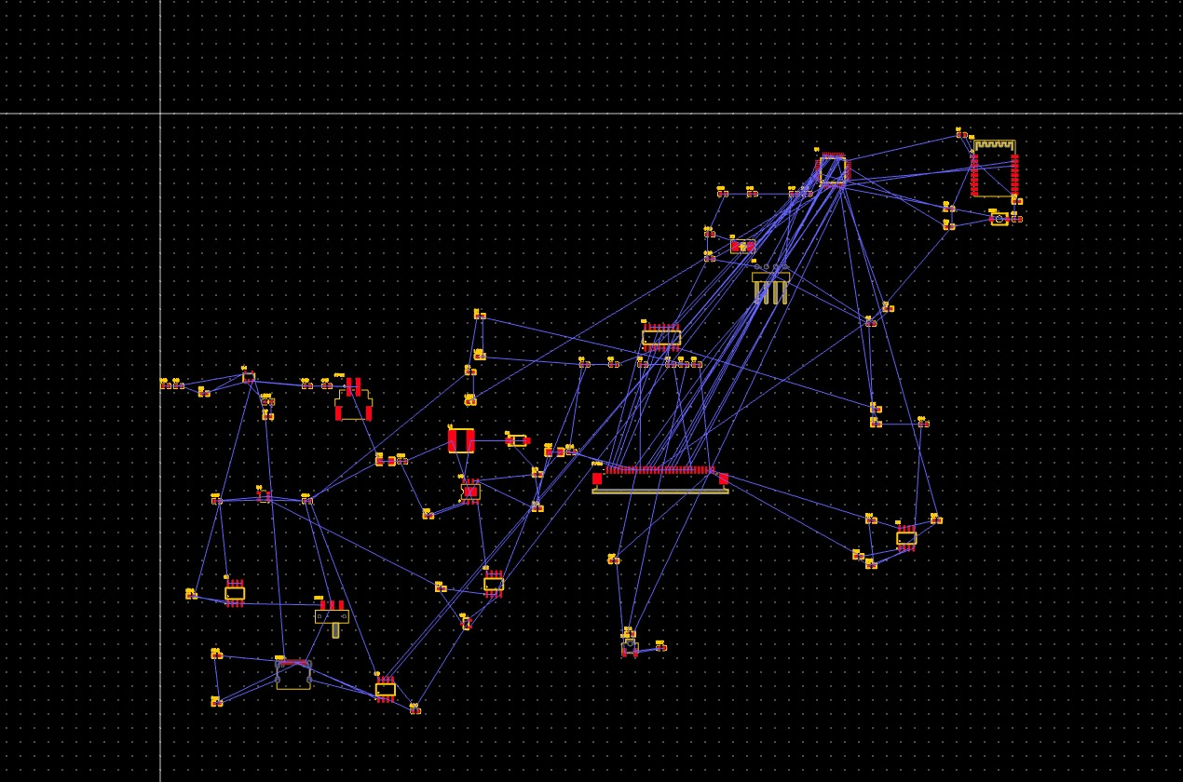

接下⾥就是我们要把这个PCB的尺⼨设计好，不然的话到时候装机就会出问题

⾸先绘制⼀个72x32.5的框：

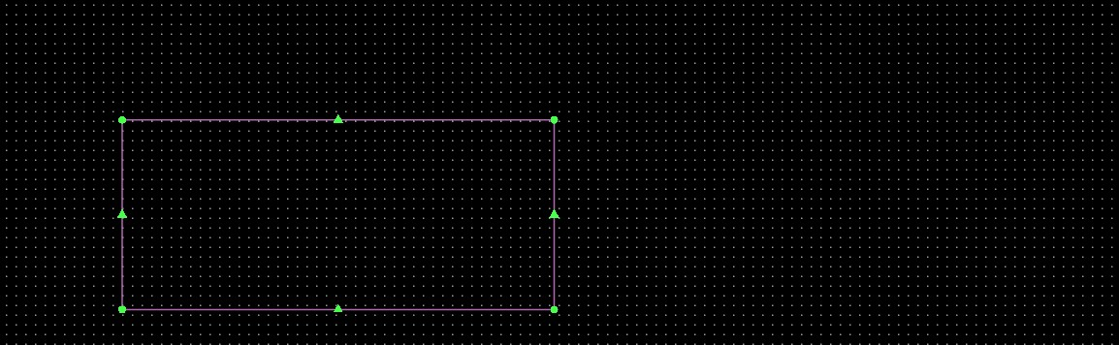

然后添加⼀个圆⻆2mm， 点击框框再右键就⾏然后根据安装的⾛向来进⾏结构的布局，就是

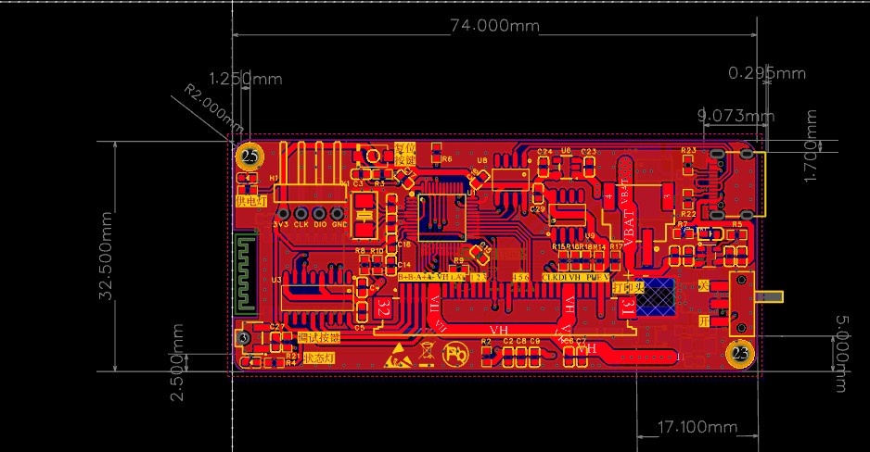

想要更快地找到元器件可以右键然后选择cross prob这样就能在pcb⾥⾯快速找到了，像这样

然后，

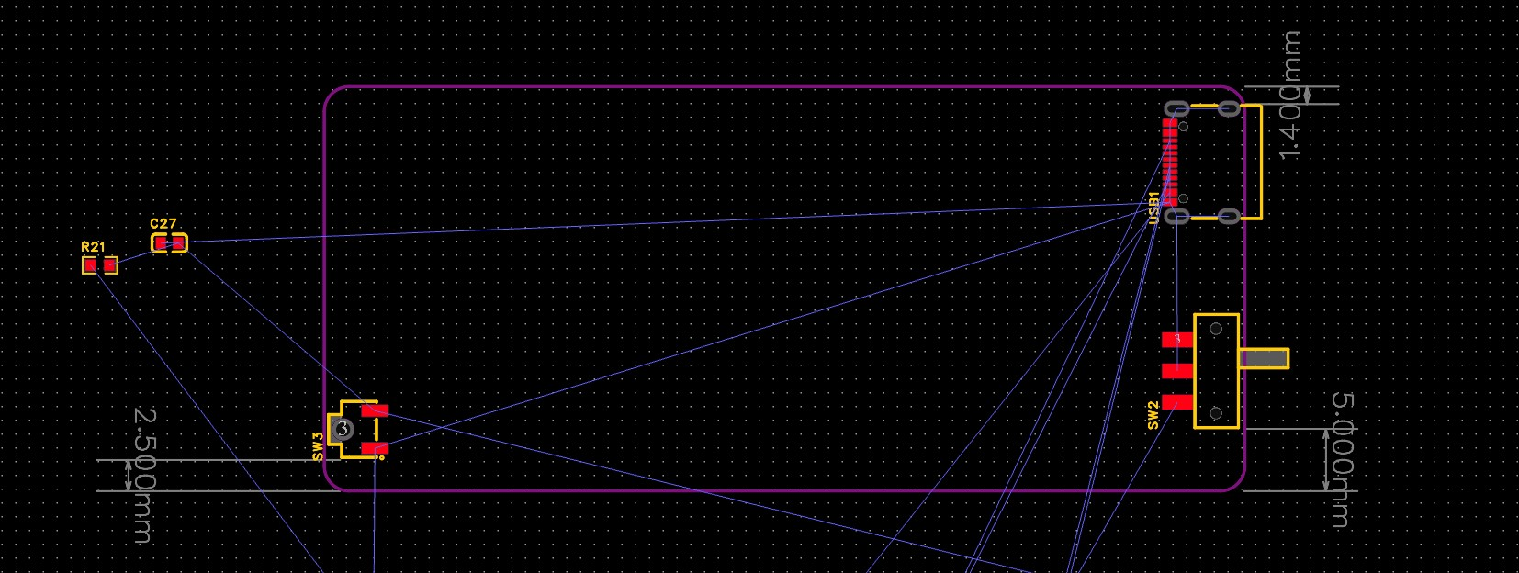

模组是蓝⽛的模组

模组是在底层的

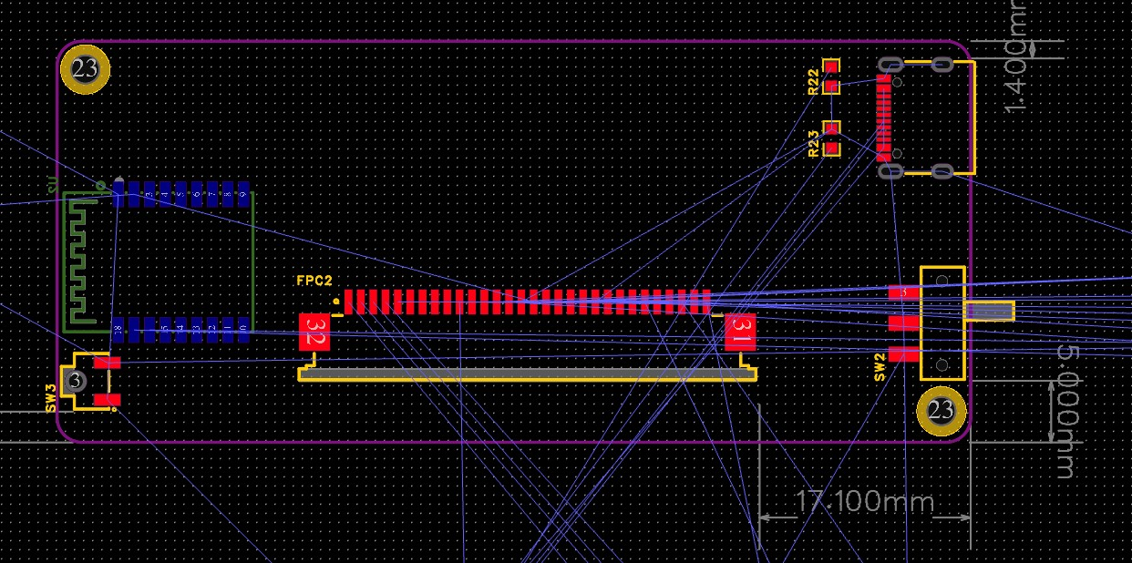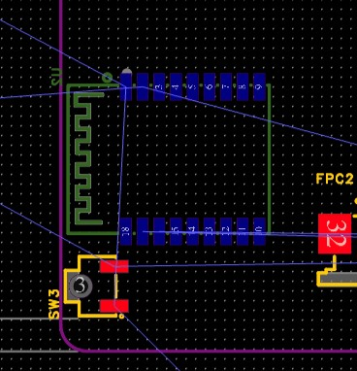

其他的外设就可以进⾏摆设了：

⼀起的外设最好是放在⼀起，这样的话能够很好的组织起来，还有布置的时候最好是把相关的配件把他们放在隔壁，这样排线的时候能够轻松⼀点：⽐如说typeC和充电管理还有⼀点要注意的话就是：



# 布线阶段

接下来就是不限阶段了，布线的话就是要通过电容电阻的线路来布线

第⼀个就是电源的⾛线，我们选择的是2mm的线路宽度点击，route，single routing进⾏布线：

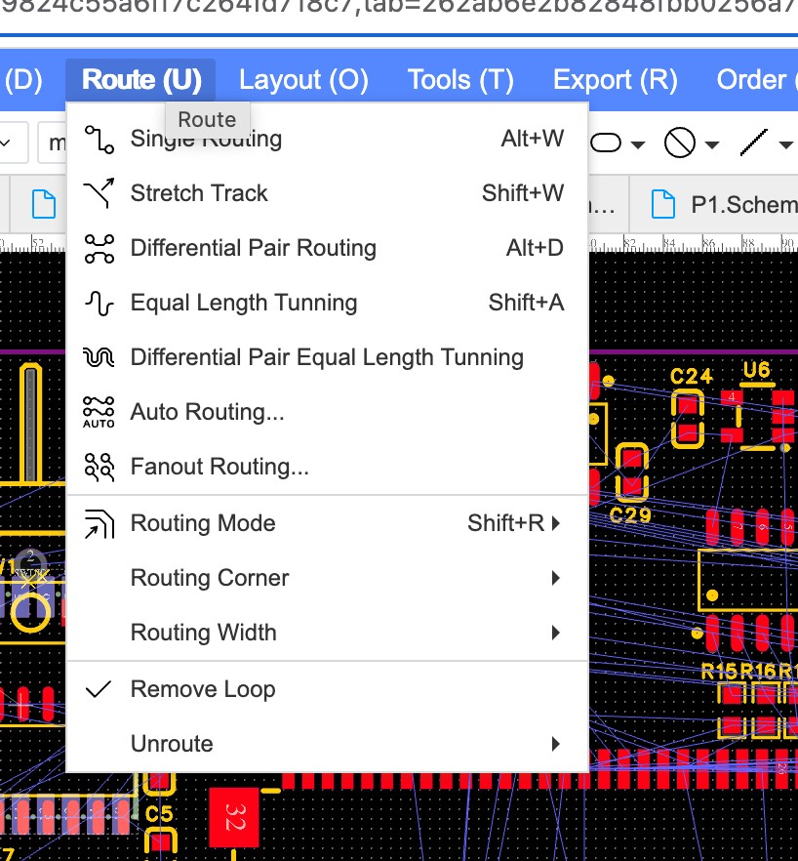

按住tab来改动宽度其他的就可以改为默认的线宽（0.254）就可以了

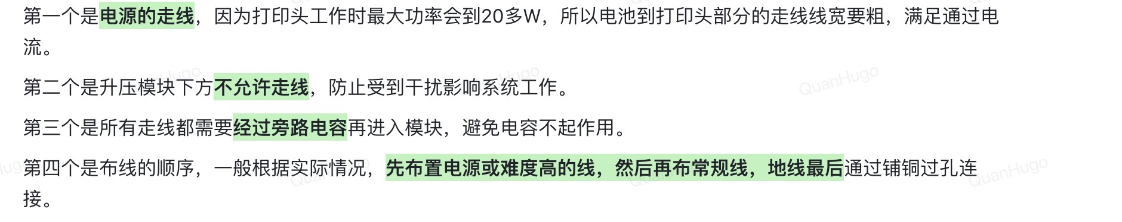

地线可以通过打孔铺铜的⽅式

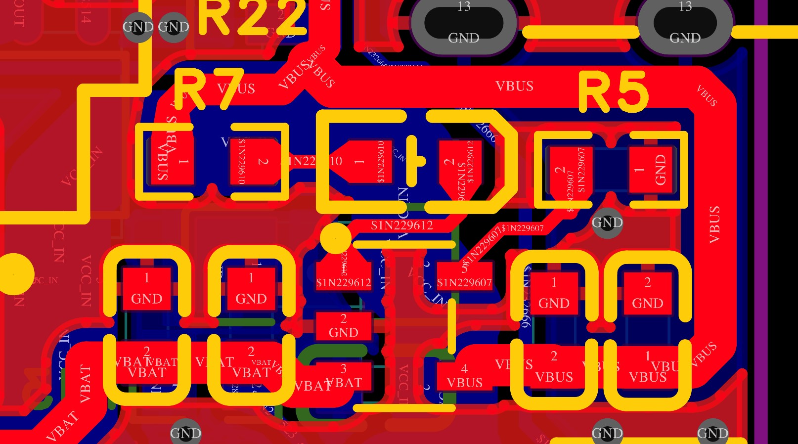

如果要连接到底层的话，就得按住alt V，进⾏过孔连接到底层

过孔可能⼀个不够得复制多⼏个：

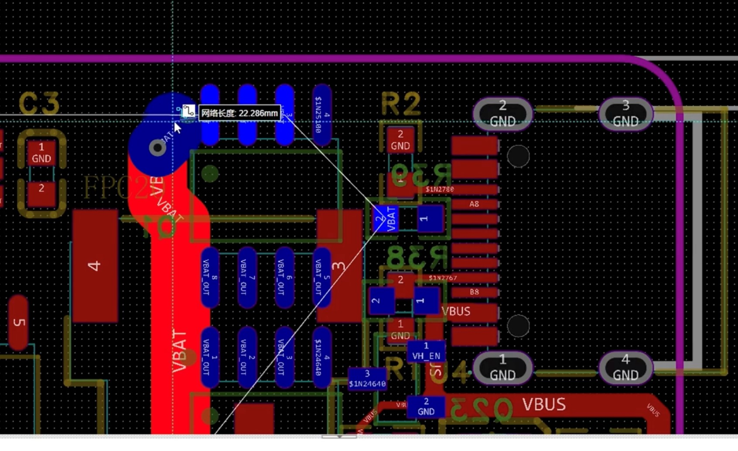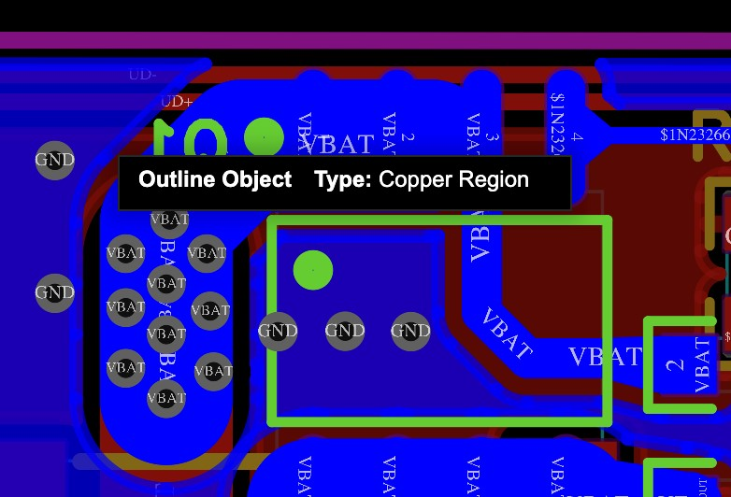

**下单加焊接阶段**下单的话，我们可以导出制版⽂件然后到官⽹进⾏下单下单的话就可以全部默认

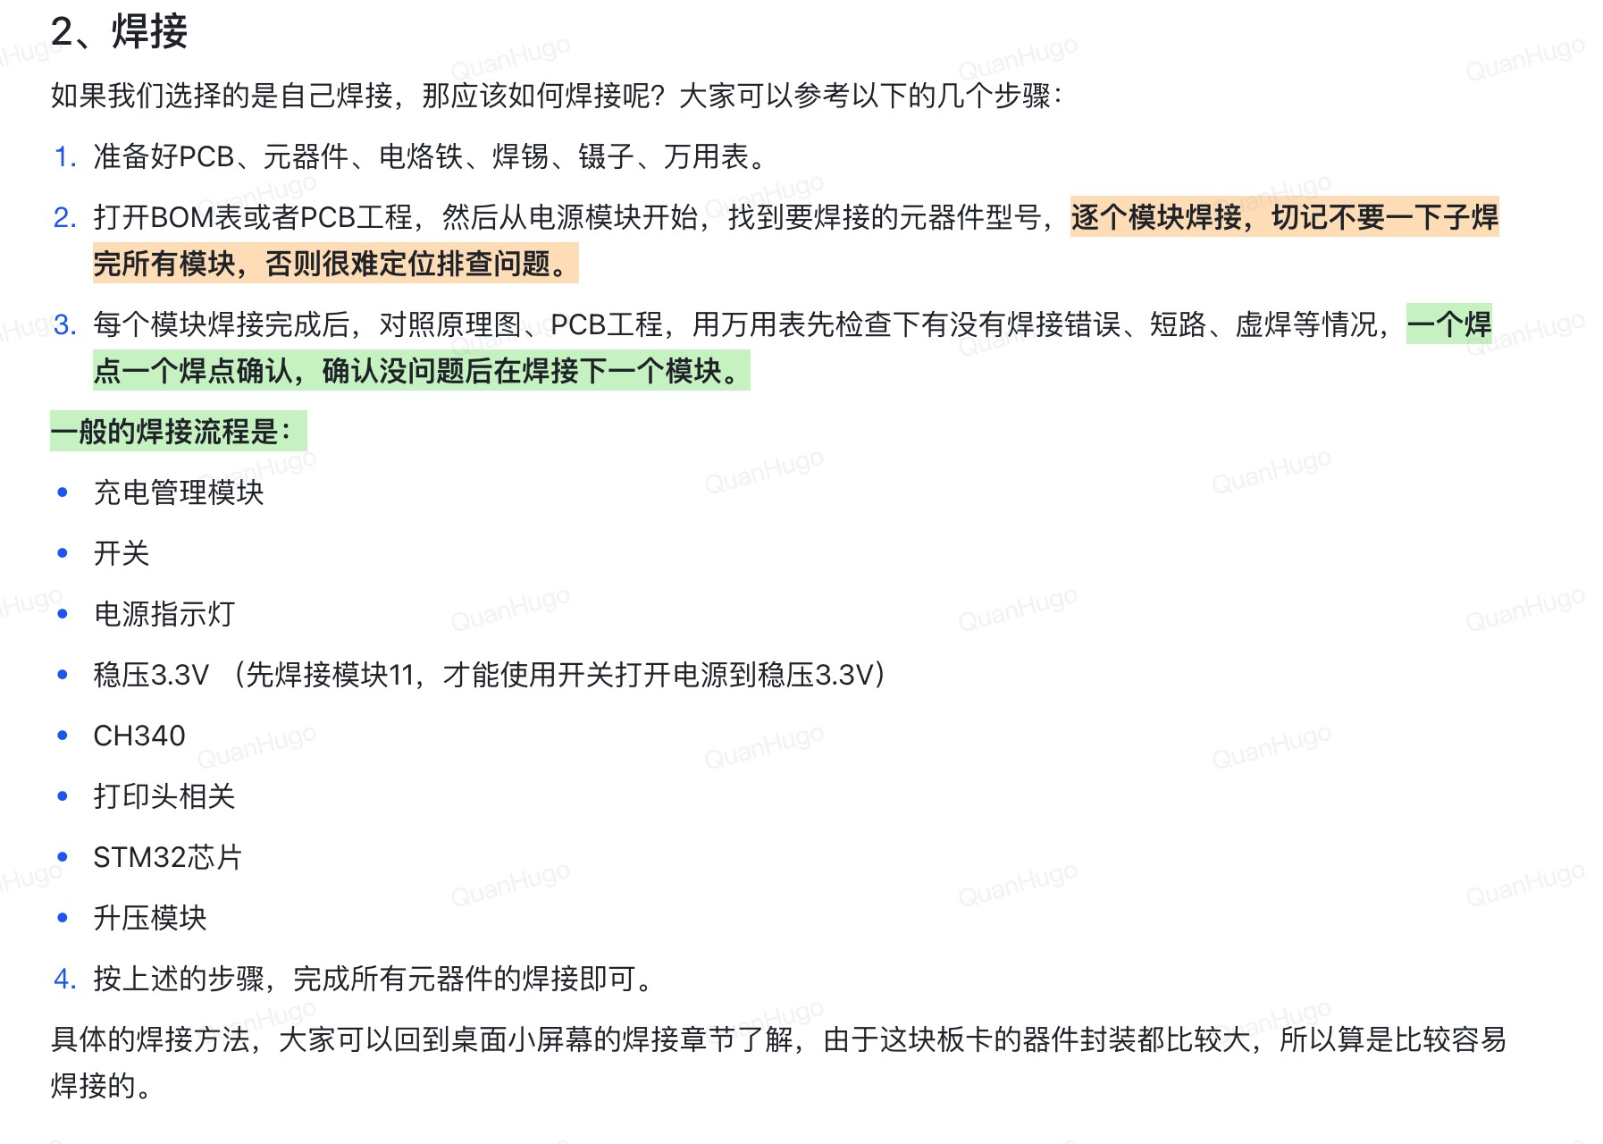

## **完善**STM32CUBEMX**的配置**

参考：<https://x509p6c8to.feishu.cn/docx/RWaHdWTHvoVIYaxNrGUcwCPzn0c>

**安装**KIELMDK**然后打开**CUBEMX**的⼯程**打开之后进⾏编译，如果编译成功就会显示0错误

# 设置烧录仿真配置

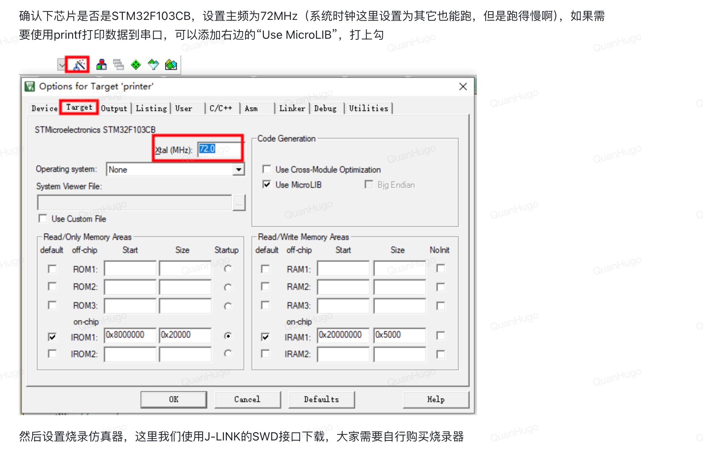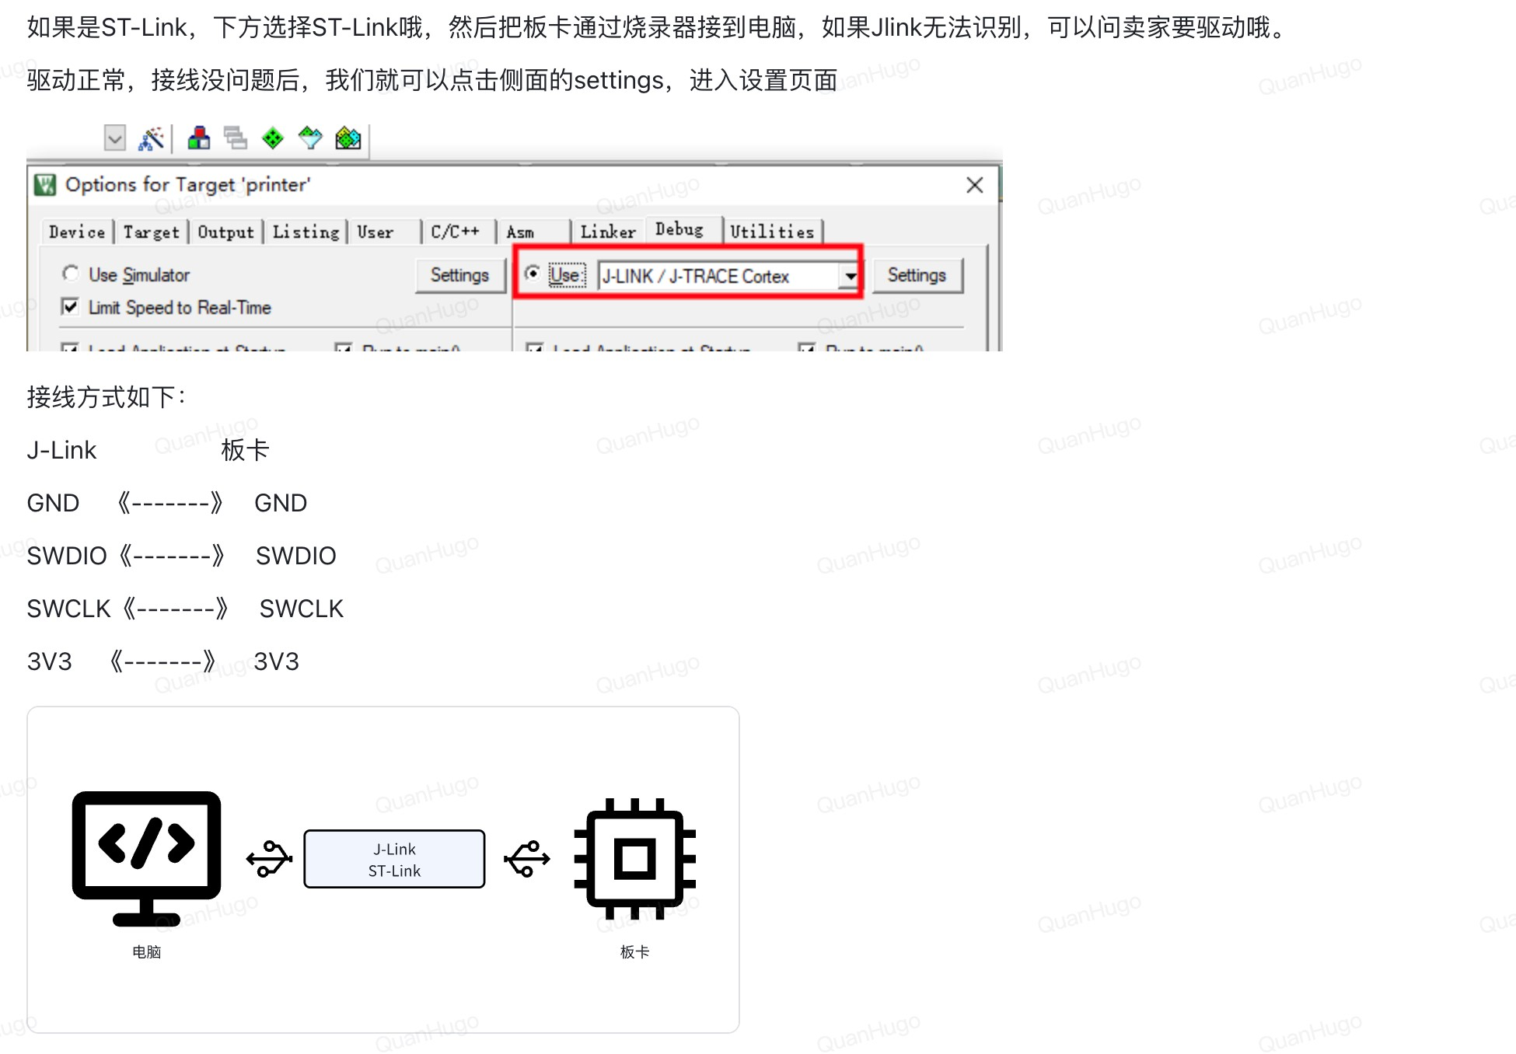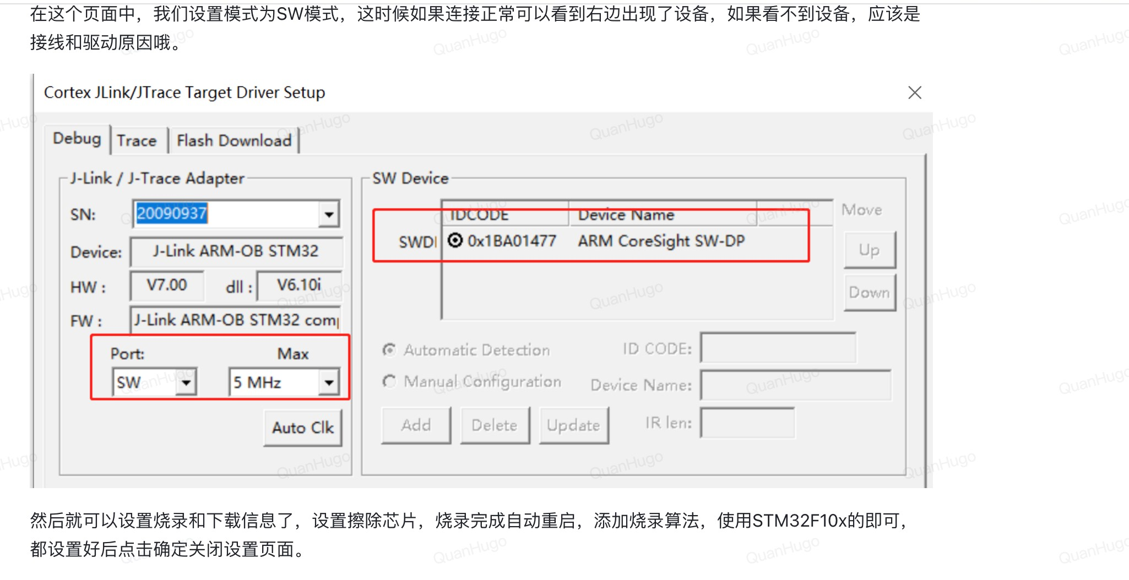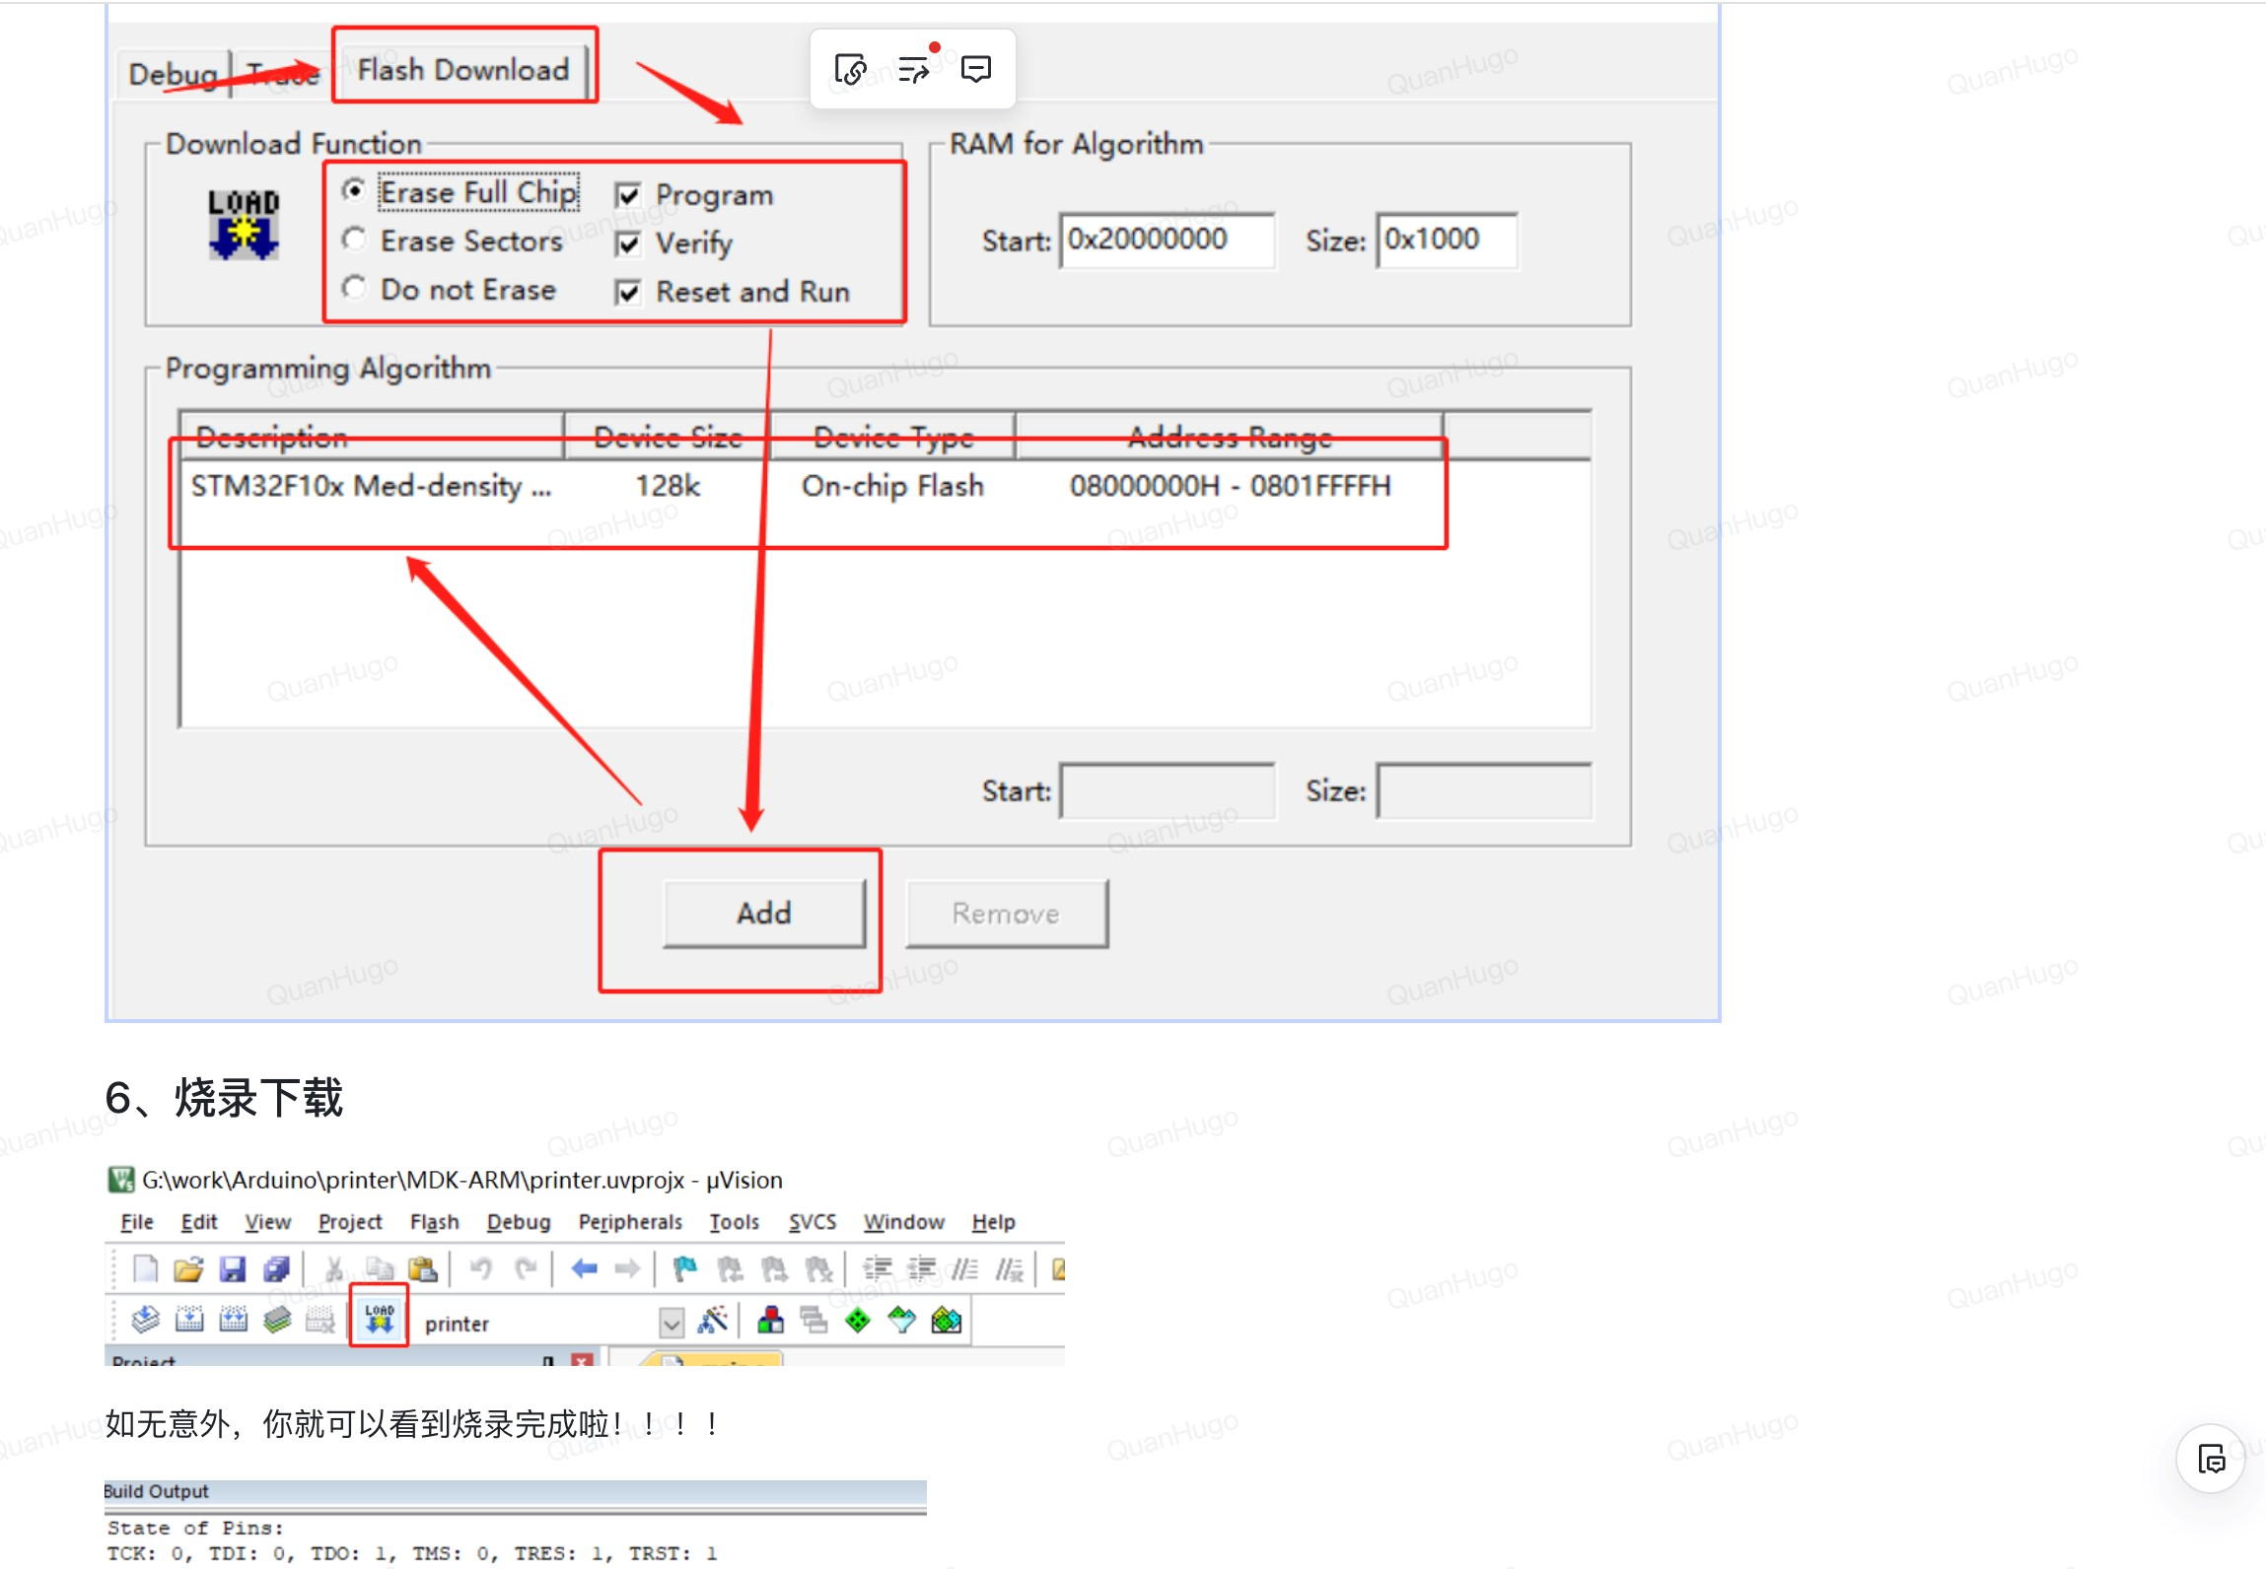

**功能实现**接下来就是真正的代码时间了

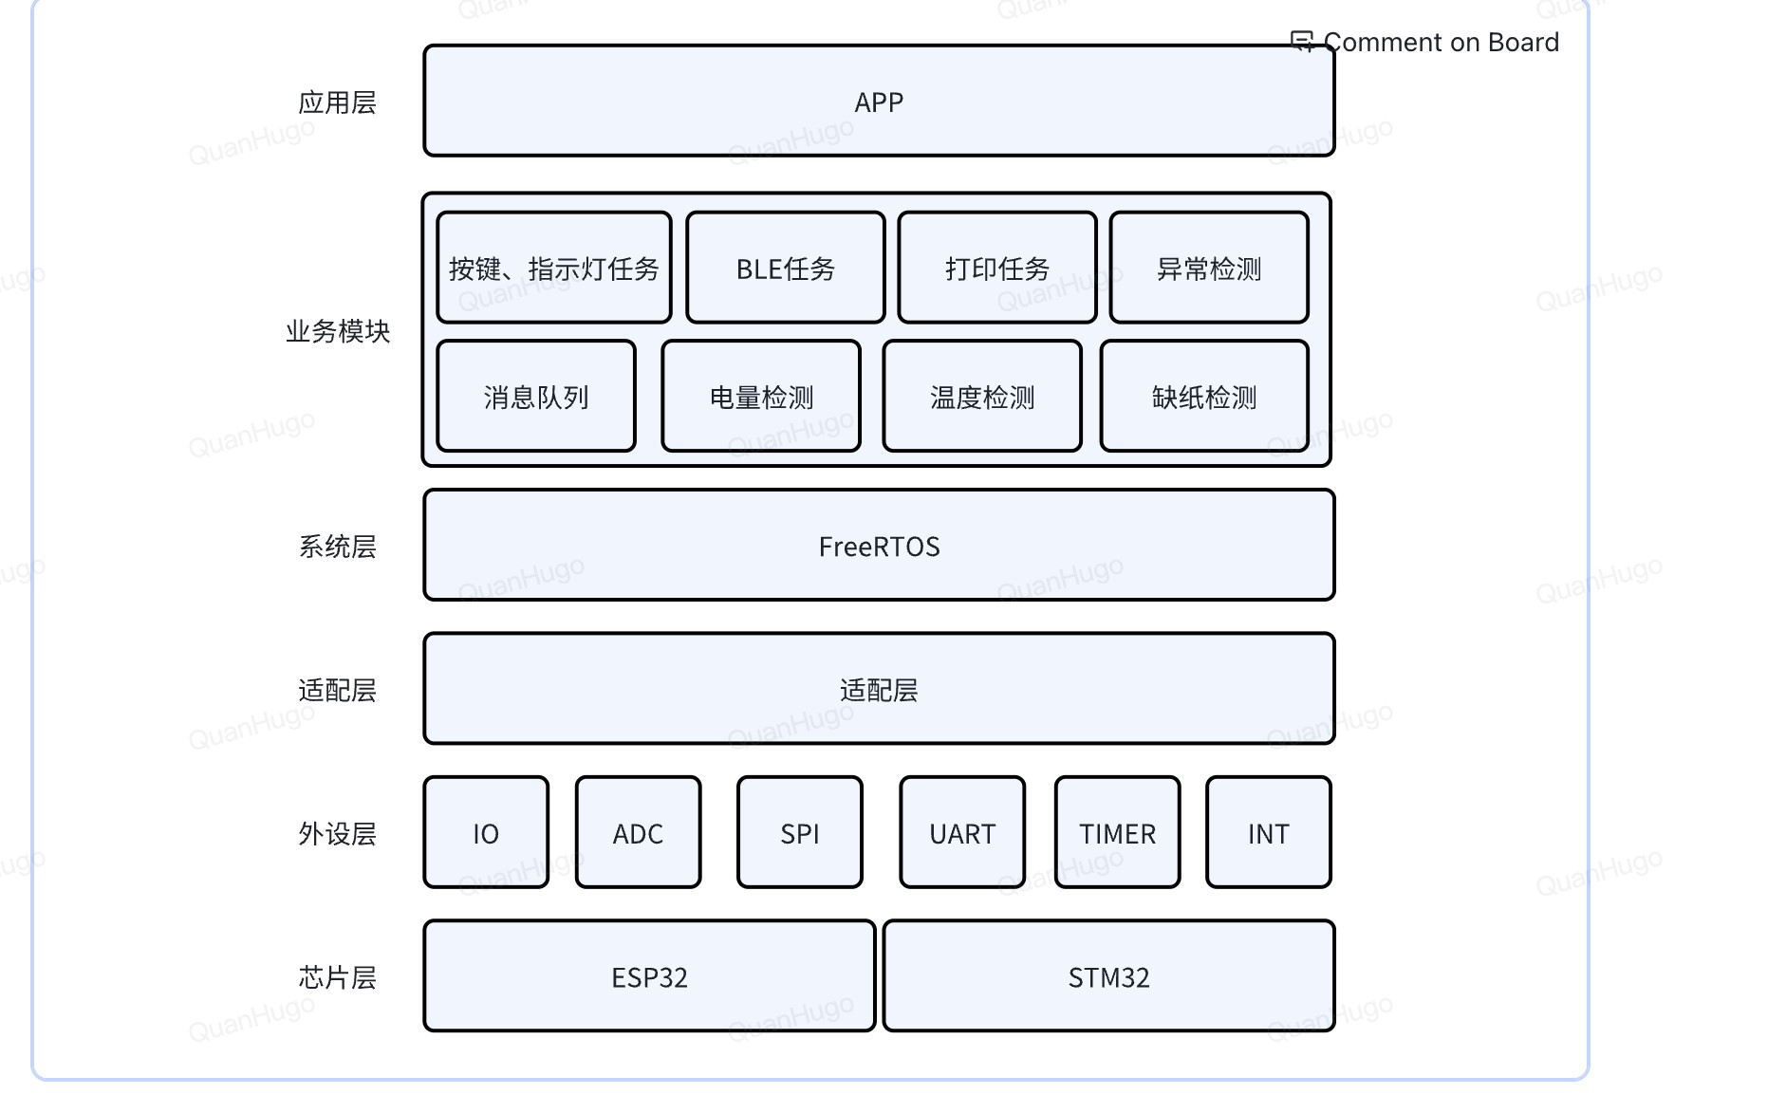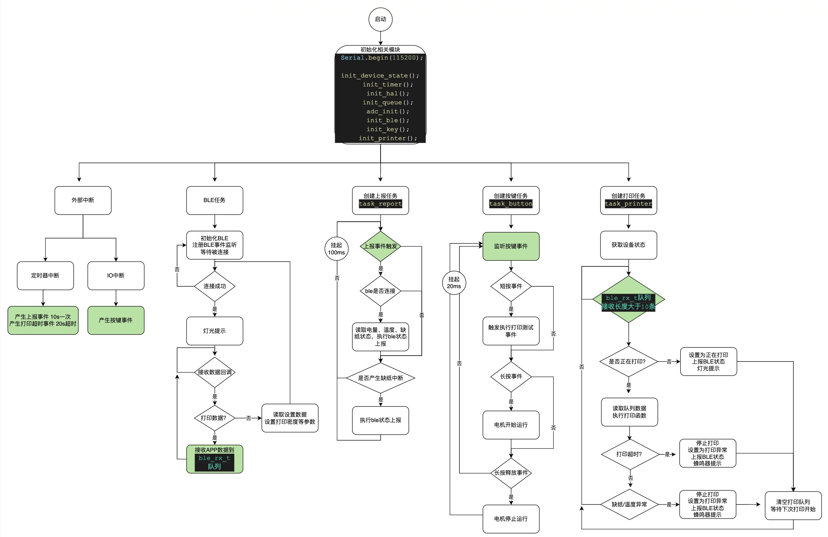

# 电量检测

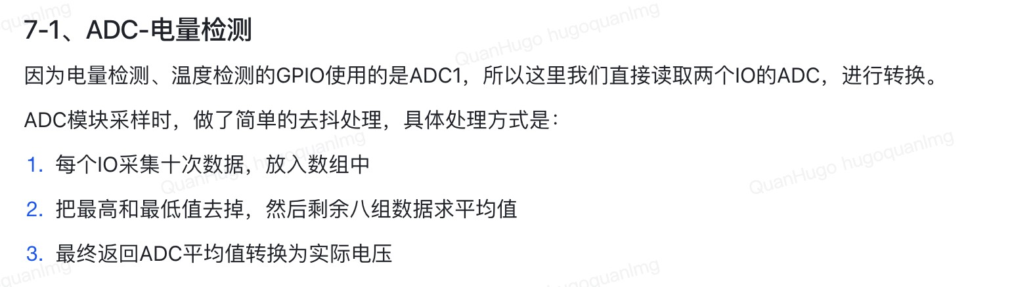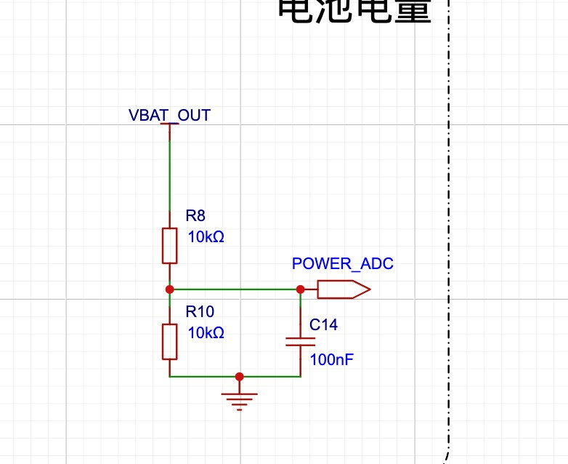

编程电量检测的话， we can read the ADC signals from two ADC (Analog-to-Digital Converter) channels, process the data, and estimate the battery level based on the measured voltage.

The way we process it is by smoothing the ADC values by limiting the highest and lowest values and just take the average of it.

extern ADC_HandleTypeDef hadc1;

#define ADC_READ_TIME 10 //adc channel will be sampled every 10 times

#define EPISON 1e-7 uint32_t ADC_Value[2]; //this array will store the processed ADC values for the two channels

void adc_init() {

HAL_ADC_Start(&hadc1); //Starts the ADC conversion

HAL_ADC_PollForConversion(&hadc1,1000); //Waits for the adc time out of

1000ms

}

//this function processes the sampled ADC data uint32_t adc_alg_handle(uint32_t *adc, int size) { uint32_t sum = 0; //sum is initially set to 0 uint32_t min_val = adc[0];//min value is 0 uint32_t max_val = adc[0]; //max value is 0

for (int i = 0; i < size; i++) { //a simple for loop for if (adc[i] < min_val) { min_val = adc[i]; //min value = adc value at I

}

else if (adc[i] > max_val) { max_val = adc[i]; //same for maximum value

}

sum += adc[i]; //add the sum

}

sum = sum - (min_val + max_val); uint32_t avg_val = sum / (size - 2); //average value obtained return avg_val; }

/**

* @brief 获取ADC引脚电压值，可根据需要加⼊滤波算法

*

* @return int

*/

//this function reads the voltage value, samples its, then processes the data int get_adc_volts()

{

uint32_t data = 0;

uint32_t adc1[ADC_READ_TIME]; //array uint32_t adc2[ADC_READ_TIME]; //array for storing sampled values

//adc read time is 10

for (int sample_ptr = 0; sample_ptr < ADC_READ_TIME; sample_ptr++)

{

//由于上⾯设置的ADC是间断模式+扫描模式，所以每采集⼀次，需要执⾏⼀次HAL_ADC_Start

HAL_ADC_Start(&hadc1); //execute HAL_ADC start

if (HAL_ADC_PollForConversion(&hadc1, 100) == HAL_OK)//waits the result pool for conversion at a time out of 100ms

{

adc1[sample_ptr] = HAL_ADC_GetValue(&hadc1);//stores the digital value from the adc at the current index

}

HAL_ADC_Start(&hadc1);

if (HAL_ADC_PollForConversion(&hadc1, 100) == HAL_OK)

{

adc2[sample_ptr] = HAL_ADC_GetValue(&hadc1);

}

HAL_ADC_Stop(&hadc1);

}

ADC_Value[0] = adc_alg_handle(adc1, ADC_READ_TIME); //uses the function to process the data from these two arrays holding the sampling data

ADC_Value[1] = adc_alg_handle(adc2, ADC_READ_TIME);

//converts the adc value back to voltage value:

Voltage (V) = (ADC Value) * (Reference Voltage / Resolution)

= (ADC Value) * (3.3V / 4096)

printf(" ADC channel0 end value = ->%1.3fV \r\n", ADC_Value[0] * 3.3f / 4096); printf(" ADC channel1 end value = ->%1.3fV \r\n", ADC_Value[1] * 3.3f / 4096); data = ADC_Value[0] * 3.3f / 4096; HAL_ADC_Stop(&hadc1);

return data; }

//this function maps a value of x from one range to another. Basically maps voltages to battery percentages.

static long map(long x, long in_min, long in_max, long out_min, long out_max) { const long dividend = out_max - out_min; const long divisor = in_max - in_min; const long delta = x - in_min;

if(divisor == 0){ //this ensures that if the input range is 0

return -1; //AVR returns -1, SAM returns 0

}

return (delta * dividend + (divisor / 2)) / divisor + out_min;

}

void read_battery()

{

//这⾥我们认为电压在3.3V为0%电量，4.2V为100%电量，进⾏转换

get_device_state()->battery = map(get_adc_volts()*2,3300,4200,0,100); //The voltage returned by get_adc_volts() is multiplied by 2. This adjustment compensates for a voltage divider circuit used to measure higher voltages than the ADC can directly read. The factor of 2 indicates that the voltage has been scaled down by half before reaching the ADC, so multiplying by 2 restores the original voltage value. Maps from 3.3V at 0 percentage to 4.2 at 100%

if(get_device_state()->battery > 100) get_device_state()->battery = 100; //if the calculated battery percentage is at 100 clip it at 100.

printf("battery = %d\n",get_device_state()->battery); //prints the battery

}

ADC-

**温度检测**

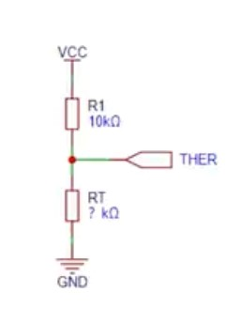

热敏电阻会随着温度的变化从⽽变化，so with voltage division, we can find out what

is the value of the THER tag is, and thus we can find out the temperature

The formula for sampled data ADC_Value = VR * 4096 / 3.3 , VR is voltage across the resistor divider

This formula can be rearranged to ADC_Value = 3.3 * R / (Rt + R) * 4096 / 3.3 = R / (Rt + R) * 1024

voltage divider

We can then find Rt from this and

The thermistor's resistance (Rt) is related to temperature using the formula:

Rt = Rp * exp(B * (1/T1 - 1/T2))

Rp is the resistance of the thermistor at a reference temperature (usually 25°C). At

25 degrees it’s usually 30k

B is the thermistor's material constant (B-value).

T1 is the absolute temperature (in Kelvin) at the desired measurement. T2 is the reference temperature in Kelvin (25°C = 298.15 K). From 25 + 273.15

Thus we can calculate temperature by rearranging:

T = 1 / ( (1/T1) + (log(Rt/Rp) / B) ) - 273.15

Rp is the fixed resistor value in the voltage divider at T2. It’s about 30k at 25degrees.

Rt is the thermistor resistance at a measured temperature T1

B25/50 = 3950K ± 1% indicates the thermistor's B-value, which is typically provided by the manufacturer.

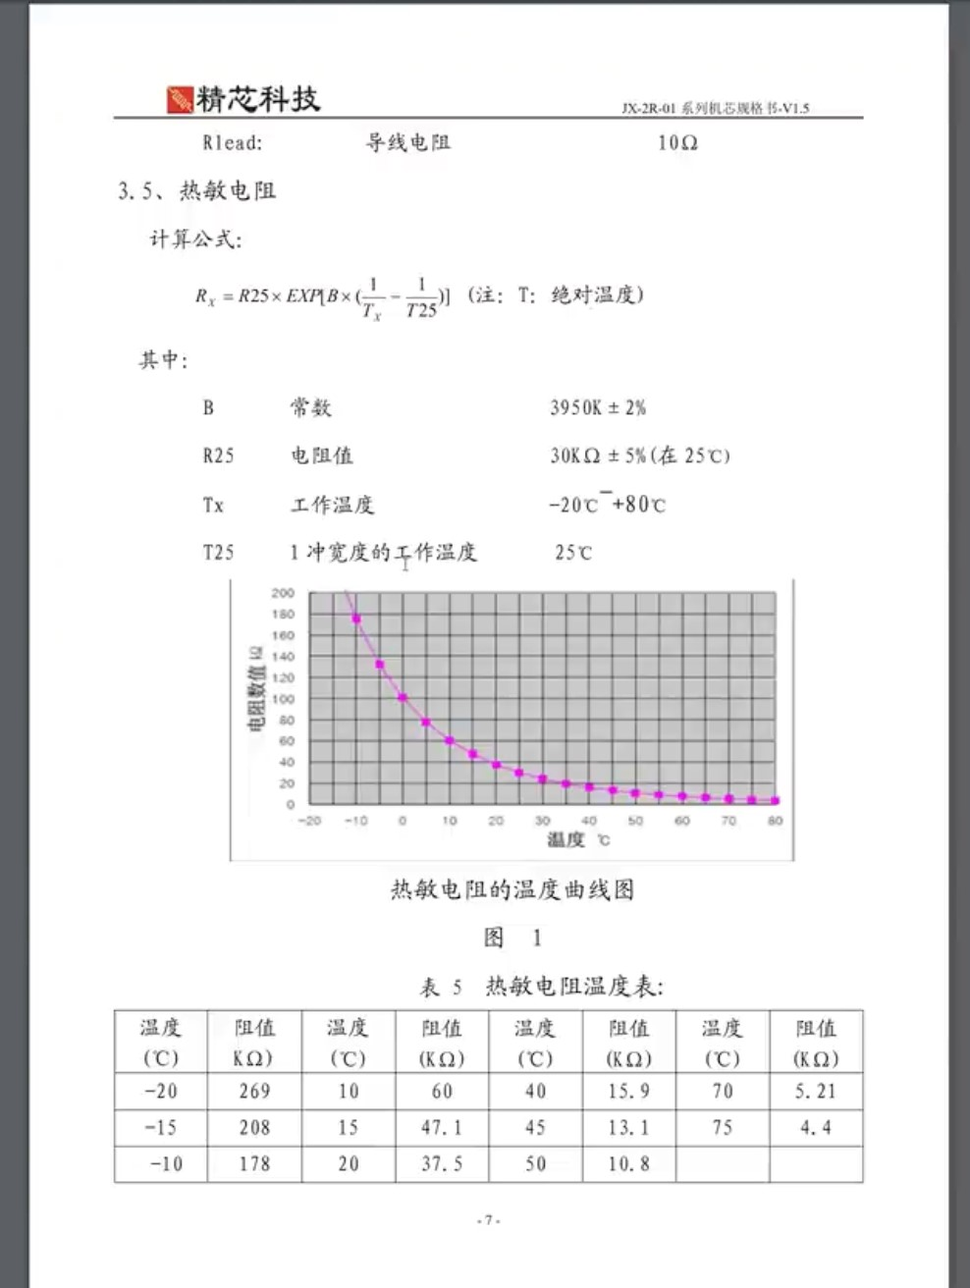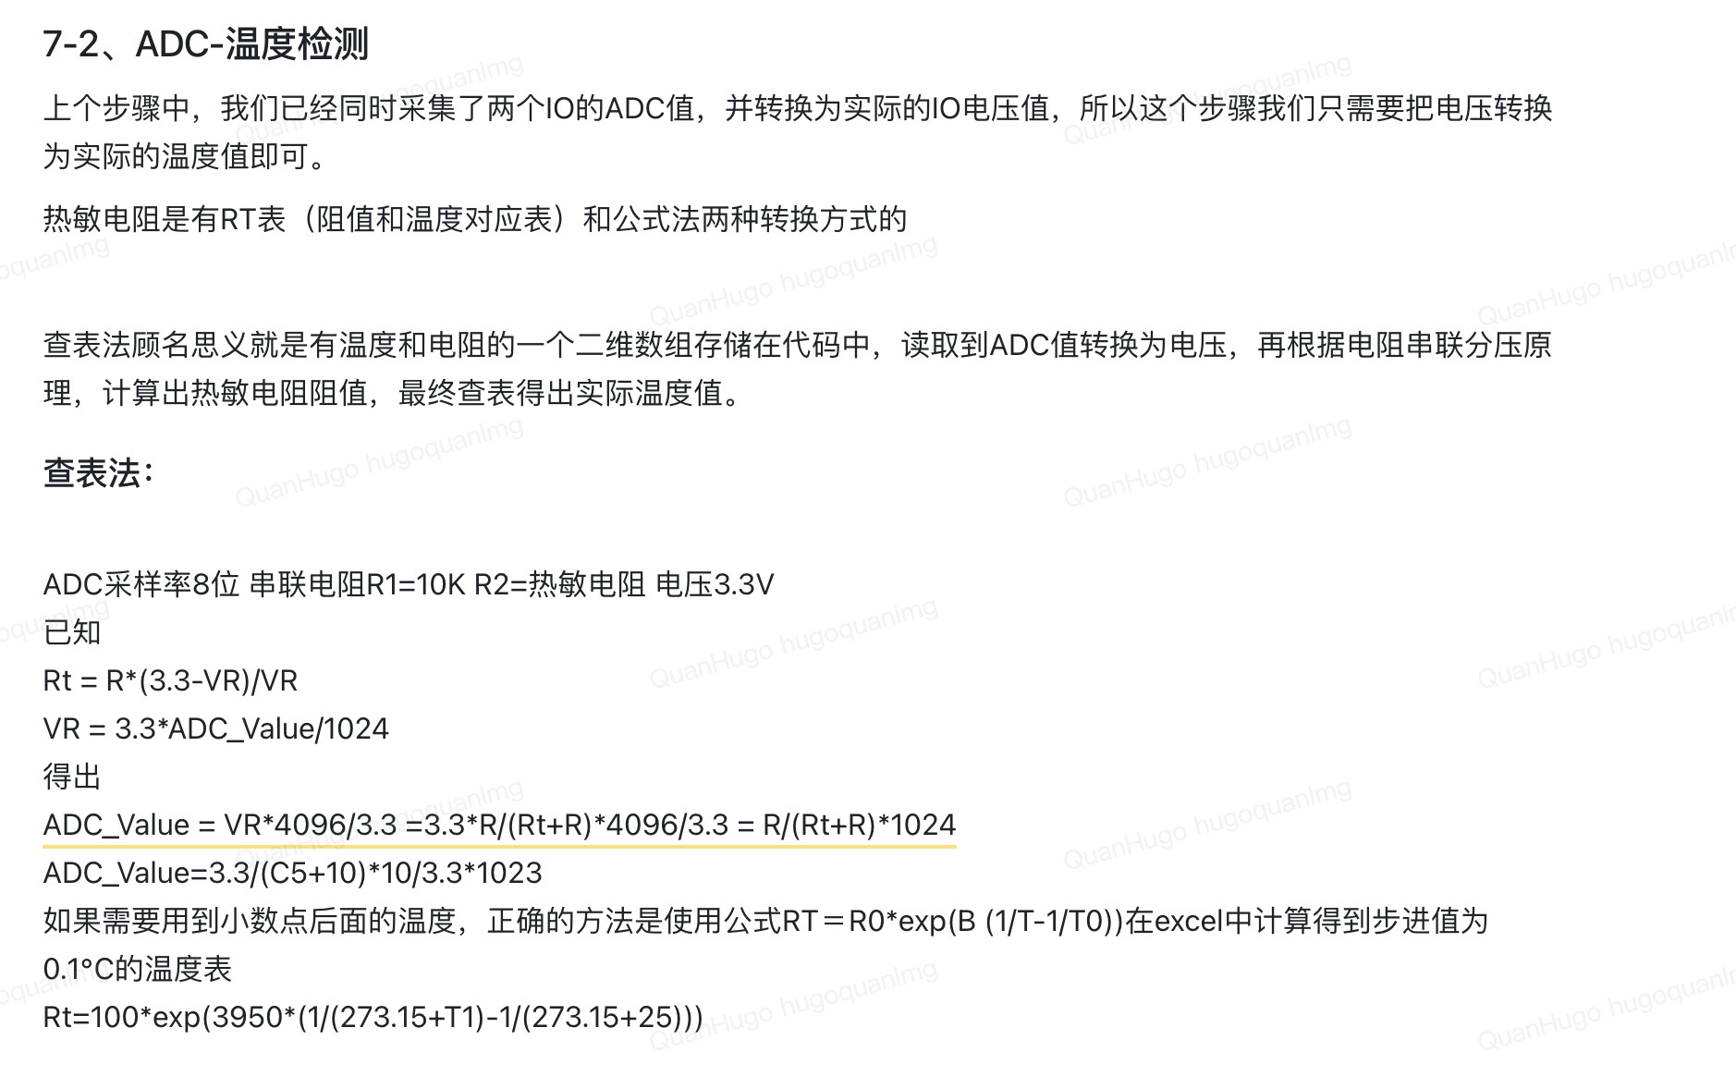

/**

* @brief 阻值转换温度

*

* @param Rt 热敏电阻阻值
* @return float 返回摄⽒度温度

*/

This function calculates the temperature using Rt

float em_temp_calculate(float Rt)

{

float Rp = 30000; // 30k float T2 = 273.15 + 25; float Bx = 3950; // B值 float Ka = 273.15; float temp = 0.0f; temp = 1 / (log(Rt / Rp) / Bx + 1 / T2) - Ka + 0.5; return temp; }

/**

* @brief Get the adc temperatrue object

*

* @return float

*/

//this function gcalculates the Rt and then uses Rt to calculate temperature by first converting adc to voltage and then voltage to

float get_adc_temperatrue(){

float temp = 0.0f; float Rt=0;

float vol=0;

//ADC转换为电压 vol=AD/4096*VCC

vol=(float)ADC_Value[1]*3.3f/4096;

printf("ADC temperatrue analog value = %f\n",vol);

//电压转换为阻值 原理图为10k 1%精度 vol/VCC=Rt/(R+Rt) vol/3.3=Rt/(10000+Rt)

Rt=(vol*10000)/(3.3-vol);

printf("ADC temperatrue Rt = %f\n",Rt);

temp = em_temp_calculate(Rt);

return temp; }

This function void em_adc_test(){ float Rt=0; float vol=3.0f;

Rt=(vol*10000)/(3.3-vol);

printf("Rt = %f\n",Rt);

Rt = 60000; //60k 10°C float temp = 0.0f; temp = em_temp_calculate(Rt); printf("temp = %f\n",temp);

if(temp >= 1e-7){ printf("正\n");

}else{

printf("负\n");

} }

## UART for printf

In embedded systems, the standard printf function does not have a default output destination, so it needs to be redefined to send data to a specific communication channel, such as a UART.

We can use UART 1 as the signal for printingF function

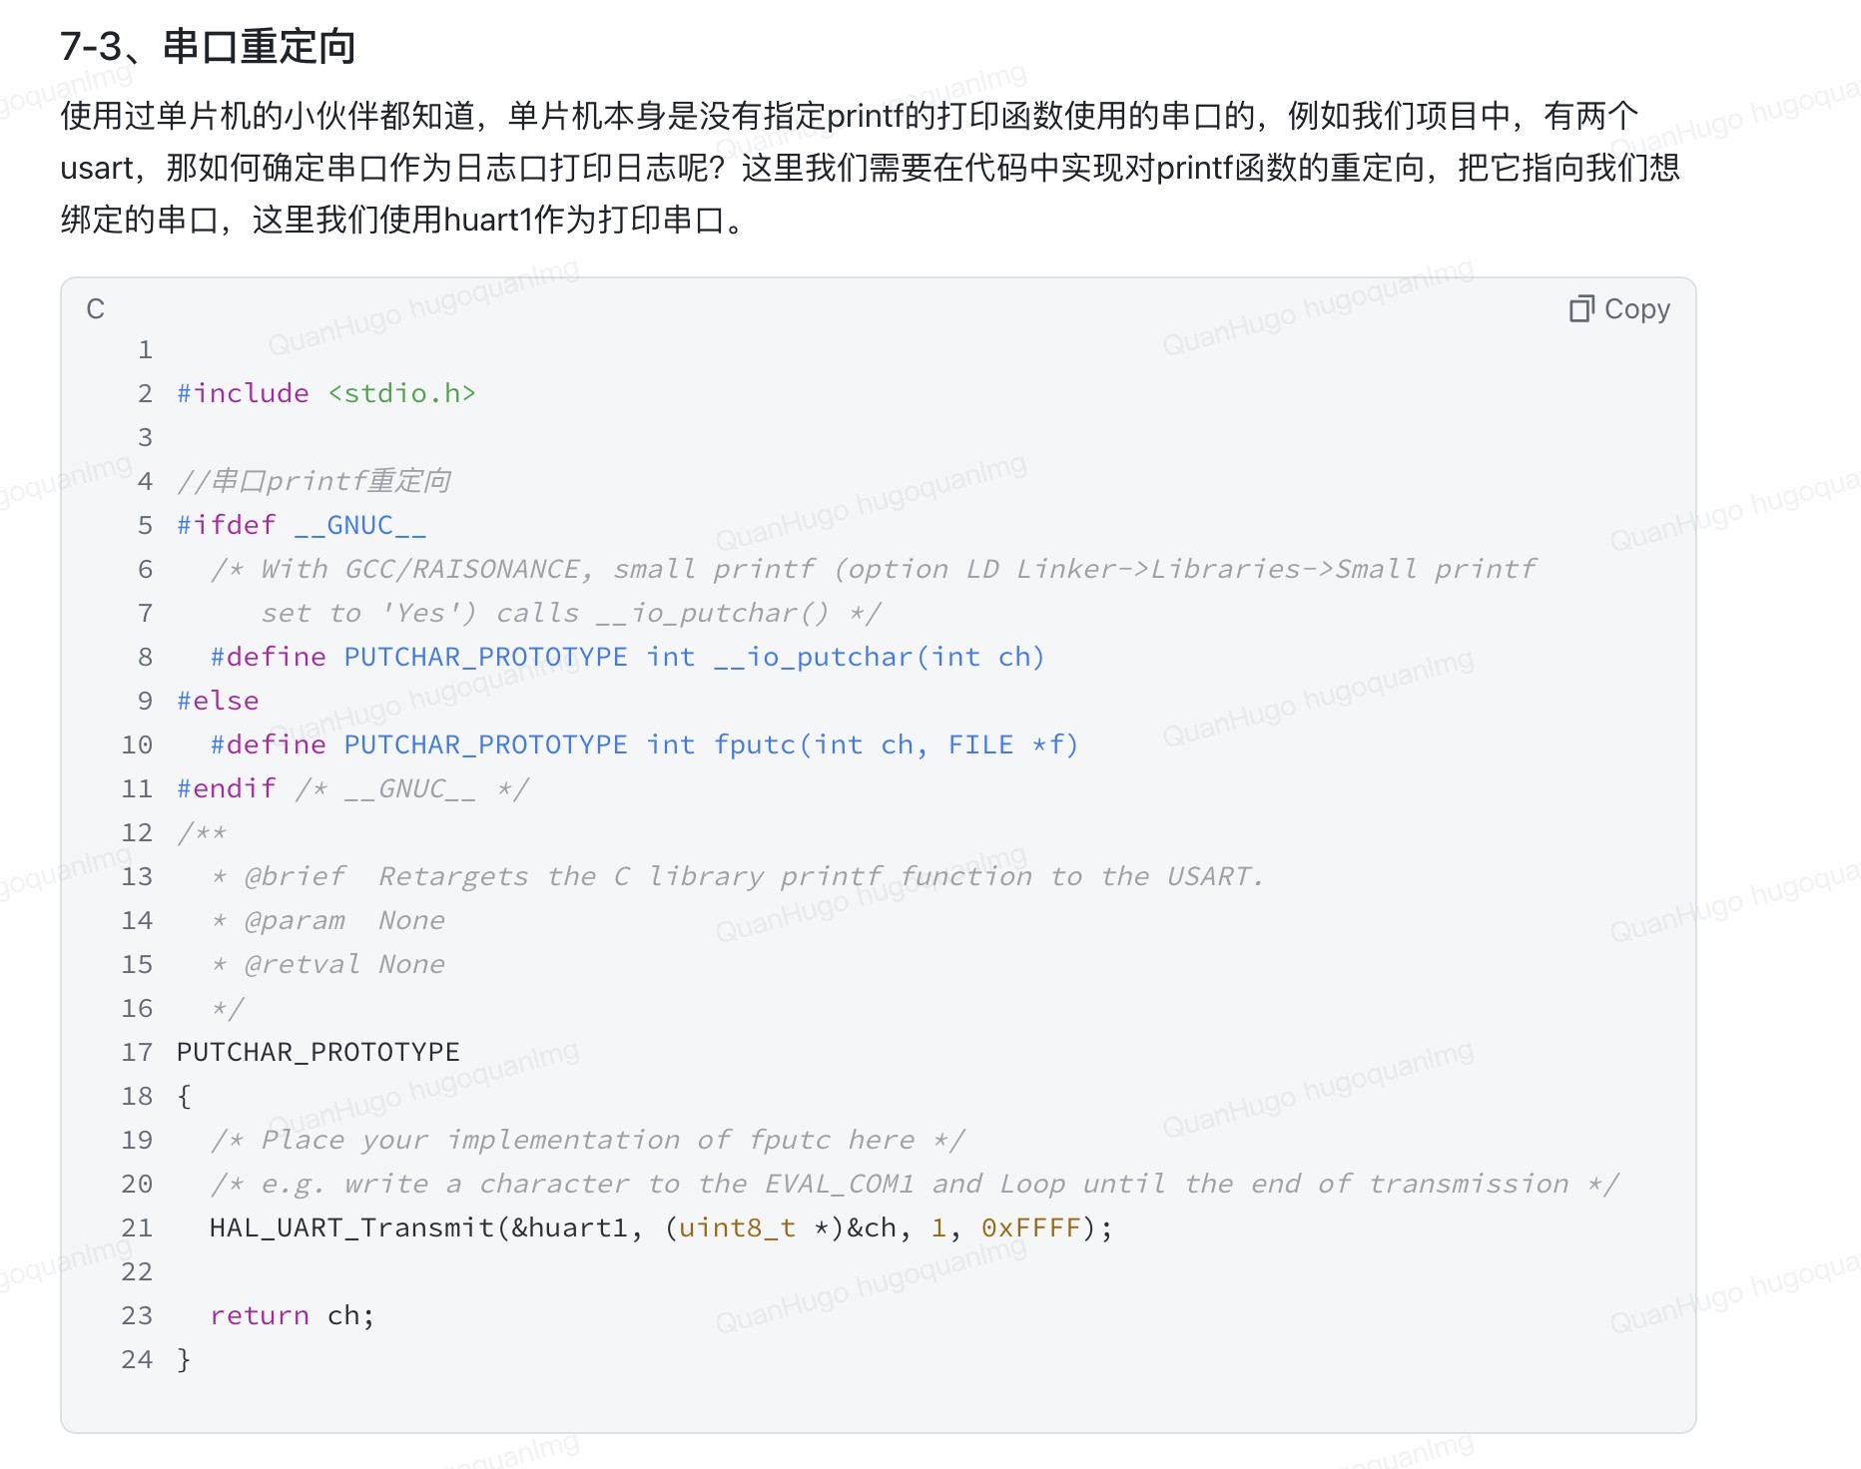

#ifdef __GNUC__

/* With GCC/RAISONANCE, small printf (option LD Linker->Libraries->Small printf set to 'Yes') calls __io_putchar() */

#define PUTCHAR_PROTOTYPE int __io_putchar(int ch) #else

#define PUTCHAR_PROTOTYPE int fputc(int ch, FILE *f)

#endif /* __GNUC__ */

This section defines a macro PUTCHAR_PROTOTYPE based on the compiler being used:

* If GCC (GNU Compiler Collection) is being used, it defines

PUTCHAR_PROTOTYPE as int __io_putchar(int ch). This function (__io_putchar) is expected by GCC when using a small printf implementation.

HAL_UART_Transmit(&huart1, (uint8_t *)&ch, 1, 0xFFFF);

* HAL_UART_Transmit is a function provided by the HAL (Hardware Abstraction Layer) library for STM32 microcontrollers. This function sends data over the specified UART interface.
* &huart1 is the handle for UART1, which has been configured and initialized elsewhere in the code.
* (uint8_t *)&ch casts the character to an 8-bit unsigned integer pointer, which is the expected data type for transmission.
* 1 specifies the number of bytes to send (only one character here).
* 0xFFFF is the timeout in milliseconds, representing the maximum time the function will wait for the transmission to complete.

**设备状态**

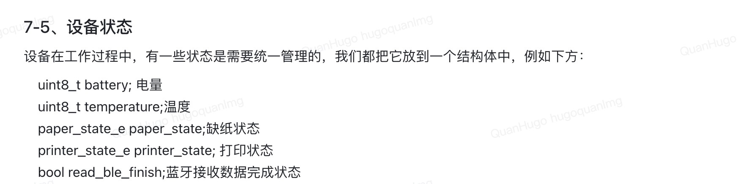

# 配置模块

主要是实现⼀些配置参数

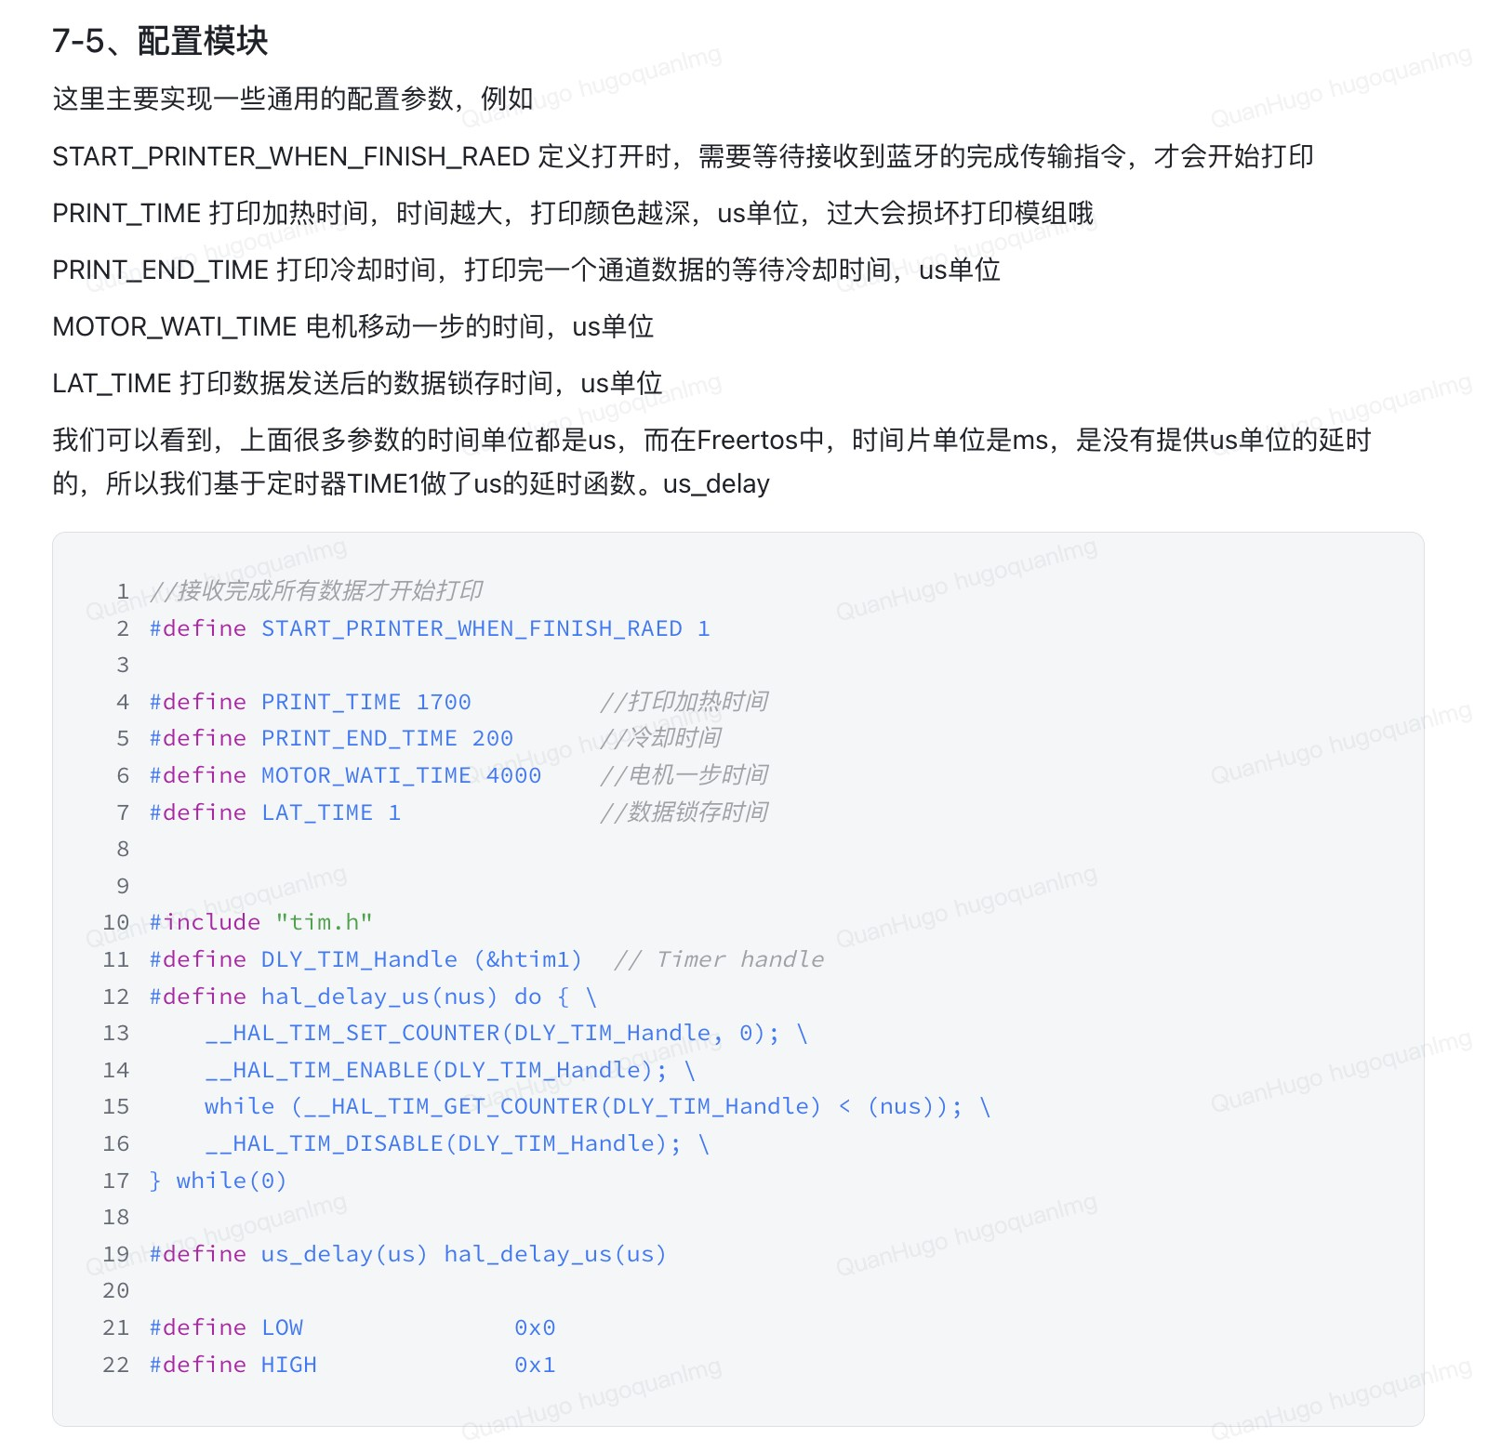

Start Printer set to 1

PRINT_TIME: The time needed to heat up the printer.

PRINT_END_TIME: The cooldown time after printing.

MOTOR_WAIT_TIME: The delay for the motor to complete its movement.

LAT_TIME: A small delay for shifting data, possibly between data transmissions.

#include "tim.h"

* This line includes the tim.h header file, which contains functions and definitions for using the timer hardware.

#define DLY_TIM_Handle (&htim1) // Timer handle

* This macro defines DLY_TIM_Handle as a pointer to the timer handle htim1. This handle is associated with a hardware timer (TIM1) configured elsewhere in the project.

#define hal_delay_us(nus) do { \

__HAL_TIM_SET_COUNTER(DLY_TIM_Handle, 0); \ __HAL_TIM_ENABLE(DLY_TIM_Handle); \

while (__HAL_TIM_GET_COUNTER(DLY_TIM_Handle) < (nus)); \

__HAL_TIM_DISABLE(DLY_TIM_Handle); \

} while(0)

* This macro defines a function to create a delay in microseconds (nus).
* Here’s how it works:
  1. Reset Timer Counter: __HAL_TIM_SET_COUNTER(DLY_TIM_Handle,

0); resets the timer counter to 0.

* 1. Enable the Timer: __HAL_TIM_ENABLE(DLY_TIM_Handle); starts the timer, allowing it to count up.
  2. Wait for Target Delay: The while loop waits until the timer’s counter reaches the specified delay (nus). It continuously checks if the timer’s counter value is less than nus.
  3. Disable the Timer: __HAL_TIM_DISABLE(DLY_TIM_Handle); stops the timer after the delay is reached.

●

This delay function is necessary because, in FreeRTOS, the minimum delay unit is milliseconds, but some functions need delays in microseconds.

1. #define LOW 0x0
2. #define HIGH 0x1

○ These are standard definitions for digital signal levels, where LOW (0x0) represents a low or zero signal, and HIGH (0x1) represents a high or one signal. They are often used to set or read the state of GPIO pins.

# 消息队列

//

⼀⾏最⼤

byte

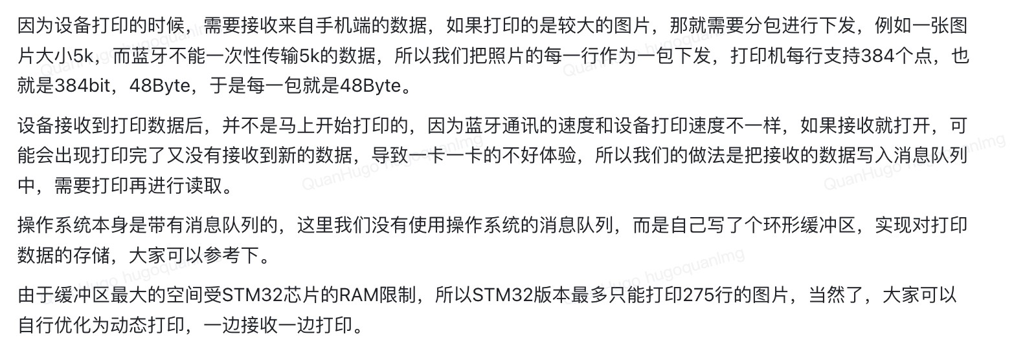

#define MAX_ONELINE_BYTE 48

// 最⼤⾏数

#define MAX_LINE 275

typedef struct

{

uint8_t buffer[MAX_ONELINE_BYTE];

} ble_rx_buffer_t;

typedef struct

{ ble_rx_buffer_t printer_buffer[MAX_LINE];

uint32_t r_index; uint32_t w_index; uint32_t left_line; } ble_rx_t; ble_rx_t g_ble_rx;

SemaphoreHandle_t xHandler = NULL;

void init_queue()

{ clean_printbuffer(); xHandler = xSemaphoreCreateMutex();

}

/**

* @brief 写⼊⼀⾏数据

*

* @param pdata
* @param length

*/

void write_to_printbuffer(uint8_t *pdata, size_t length)

{ static BaseType_t xHigherPriorityTaskWoken; if (length == 0)

return;

if (g_ble_rx.left_line >= MAX_LINE)

return;

if (length > MAX_ONELINE_BYTE) length = MAX_ONELINE_BYTE;

// 查看是否可以获得信号量，如果信号量不可⽤，则⽤10个时钟滴答来查看信号量是否可⽤

//这⾥可以设置零等待、有限等待、⽆限等待

//零等待可能会导致数据丢包，因为正在读取数据时，同时想写⼊数据，这时候是获取不到信号量的，就不会执⾏写⼊循环缓冲区操作。

//有限等待：阻塞10个时钟滴答是⼤致评估了数据读出的时⻓，保证每次写⼊时都能阻塞等待到获取信号量，代码设计时⼀般不建议⽆限阻塞。

//当然，这个模块可以使⽤rtos提供的消息队列实现，或者双缓冲区实现会更适合。

if (xSemaphoreTakeFromISR(xHandler, &xHigherPriorityTaskWoken) == pdPASS)

{

memcpy(&g_ble_rx.printer_buffer[g_ble_rx.w_index], pdata, length); g_ble_rx.w_index++; g_ble_rx.left_line++; if (g_ble_rx.w_index >= MAX_LINE) g_ble_rx.w_index = 0; if (g_ble_rx.left_line >= MAX_LINE) g_ble_rx.left_line = MAX_LINE;

xSemaphoreGiveFromISR(xHandler, &xHigherPriorityTaskWoken);

}

if (xHigherPriorityTaskWoken == pdTRUE)

{

// 如果有更⾼优先级的任务需要唤醒，则进⾏任务切换

portYIELD_FROM_ISR(xHigherPriorityTaskWoken);

} }

/**

* @brief 读取⼀⾏数据

*

* @return uint8_t*

*/

uint8_t *read_to_printer()

{

uint32_t index = 0;

// 查看是否可以获得信号量，如果信号量不可⽤，则⽤10个时钟滴答来查看信号量是否可⽤

if (xSemaphoreTake(xHandler, (portTickType)10) == pdPASS)

{

if (g_ble_rx.left_line > 0)

{

g_ble_rx.left_line--; index = g_ble_rx.r_index; g_ble_rx.r_index++; if (g_ble_rx.r_index >= MAX_LINE)

g_ble_rx.r_index = 0; xSemaphoreGive(xHandler); return g_ble_rx.printer_buffer[index].buffer;

}

xSemaphoreGive(xHandler);

return NULL;

}

else

return NULL; }

/**

* @brief 清空接收缓存
* */

void clean_printbuffer()

{

g_ble_rx.w_index = 0; g_ble_rx.r_index = 0; g_ble_rx.left_line = 0;

}

uint32_t get_ble_rx_leftline()

{

return g_ble_rx.left_line; }